Edwin Collier
March 13, 1915 – January 25, 1992
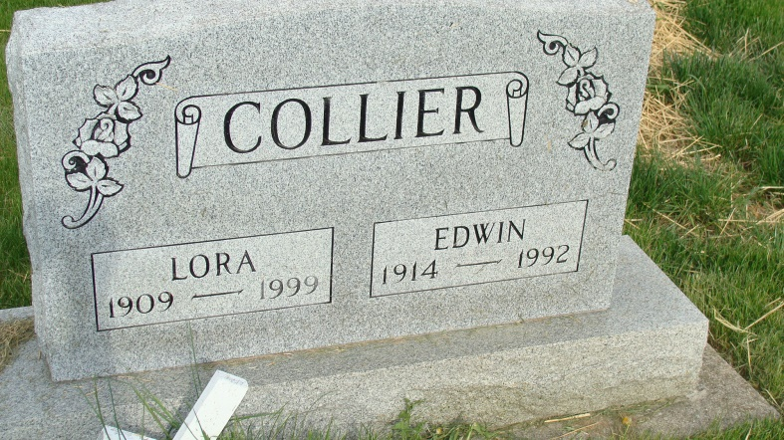
Photo by Alicia Kneuss

Edwin Collier, 77, of Berne died Saturday at Adams County Memorial Hospital, Decatur. He retired from the sanding department of Dunbar Furniture after 41 years.
He helped create the Berne Little League and was active in the Boy Scouts of America.
Surviving are his wife, Lora Carroll; a daughter, Dian R. Bollinger of Georgetown, Ky.; sons, Michael L. of Spencerville and David A. of Geneva; sisters, Opal Lefever and Mildred Boling, both of Camelsburg; five grandchildren; and two greatgrandchildren.
Services were today at Yager-Kirchhofer Funeral Home, Berne. Burial is in M.R.E. Cemetery. Preferred memorials are gifts to Berne Little League or Boy Scout Troop No. 67.

News-Sentinel, The (Fort Wayne, IN) - Monday, January 27, 1992
*****
Edwin Collier
…Edwin Collier, 77, Berne, father of a Geneva resident, died Saturday morning at Adams County Memorial Hospital, Decatur.
He retired after 41 years from the sanding department at Dunbar Furniture, Berne. He also helped in the development of Berne Little League and was on the Boy Scout staff for many years.
Surviving are his wife, Lora; two sons, including David A. Collier, Geneva; one daughter; two sisters; five grandchildren; and two great-grandchildren.
Services were held today in the Yager-Kirchhofer Funeral Home, Berne. Burial was in the MRE Cemetery there.
Memorials may be made to the Berne Little League or to Boy Scout Troop No. 67.

Commercial Review, Portland, IN; January 27, 1992

