Adele (Moser) Egly
May 19, 1894 – February 26, 1974
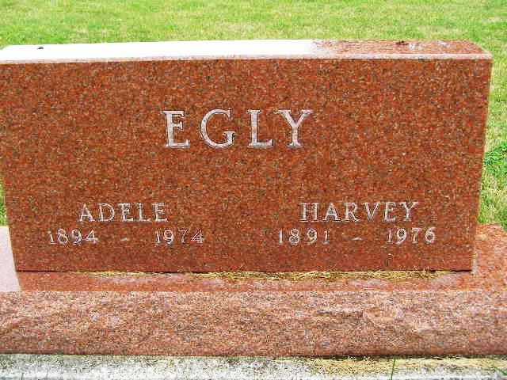
Photo by Shaunda Bedwell

WIFE OF HARVEY EGLY DIES HERE TUESDAY EVENING
Mrs. Adele Egly, 89, wife of Harvey Egly of this city, died at 6:45 p.m. Tuesday at her home, 354 Dearborn street. Death followed an illness of one year. Mrs. Egly was a lifelong resident of this city.
Mrs. Egly contracted polio in 1937 and had not been well since being shut in most of that time.
She was born in Adams county May 19, 1894, the daughter of John S. and Christine Steiner Moser. Her marriage to Harvey Egly took place at Decatur, May 17, 1912.
The husband survives, together with a daughter, Mrs. Homer [Jean] Augsburger of this city and a son, Carl Egly, Fort Wayne; three grandchildren and three great-grandchildren and a sister, Mrs. Alton Schindler, raised in the home of Mrs. Egly’s parents.
Three brothers, Paul, Levi and Daniel and seven sisters, Emma Reichert, Bertha Balsiger, Lacy Schindler, Katy Yoder, Martha Schindler and Barbara and Margaret preceded in death.
The body is at the Yager Funeral hmoe where frieds may call afternoon Thursday and where services will be held at 2 p.m. Friday. Rev. Wilson Bixler will officiate and burial will be in the M.R.E. cemetery.

Burial on Lot 597 Orig Platt …Burial Date: 2 March 1974
Berne (IN) Library Heritage Room
MRE Obits 1973-1984, PTDC0050
Transcribed by Joey Pedigo

