Florine Rosina (Steury) Fennig
March 26, 1926 – December 18, 2012

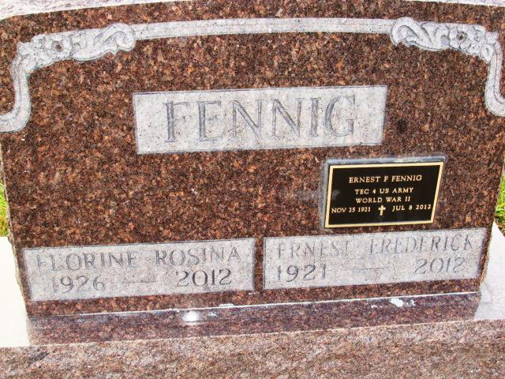
Photo by Alicia Kneuss

Florine Rosina Steury Fennig, 86, of Berne passed away on December 18, 2012. She was born on March 17, 1926 on the family farm in Adams County to David P. and Mary Habegger Steury.
Flo was the middle of nine children and graduated from Monroe High School in 1944. She was the first from her family to go to college. Sponsored by the U.S. government, she graduated as a Cadet Nurse after three years of training at Michael Reese Hospital in Chicago. She then worked at hospitals in Portland, In. and Fort Wayne,, In.(St. Joseph).
She married Ernest Federick Fennig on August 6, 1950 at the First Missionary Church in Berne. Together they lived in Indianapolis, where they were members of Hope Church and Castleview Baptist Church. Flo was active in the Christian Women's Club at both churches. As a nurse, she worked at Methodist Hospital and for the office of Dr. George Teter, pediatrician, for 18 years. 60-year residents of Indianpolis, the Fennigs moved back to Berne in 2010.
A loving mother, sister, grandmother, and friend, Flo was an excellent seamstress, gardener, pie baker, and a lover of music, especially the hymns of the church.
She was preceded in death by her parents; brothers Frank, Clint, and Dr. Ernie Fennig; sisters, Clara Sprunger, Ruth Sprunger, Mary Alice Lehman Waren; husband Ernest Fennig and sons George Michell and Dr. John Fennig.
Visitation will be on Wednesday, December 26 from 4 to 7 pm and the memorial service at 11 am on Thursday, December 27, both at Swiss Village, 1350 W. Main St. Berne, In. Officiating is Pastor Max Haines. Burial in the MRE Cemetery, Berne.
Preferred memorials to the Swiss Village Samaritan Fund.
Yager-Kirchhofer Funeral Home online obit (accessed 5/5/2013)

