Clella (Brickley) Gottschalk
January 6, 1896 – August 17, 1971

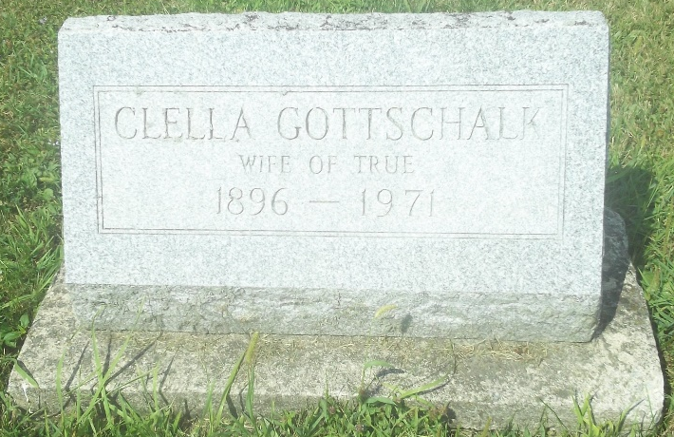
Photo by DSON 1492

Clella Gottschalk

Date of Death: August 17, 1971; Date of Burial: August 20, 1971
Burial: Lot 49, Original Platt

Mrs. Clella Gottschalk Dies at Fort Wayne

Mrs. Clella (Brickley) Gottschalk, 75, of 1918 Pemberton Drive, Fort Wayne, and a native of this community, passed away last night according to information telephoned to relatives here today. She was the widow of Dr. True Gottschalk, who died while still a young man.
Mrs. Gottschalk was a cousin of Mrs. Clifton H. Sprunger of Berne. She grew up here and graduated from Berne High School in 1914. During the many years she resided in Fort Swayne she was engaged in teaching in that city.
She was a member of the Plymouth Congregational Church and the Indiana Retired Teachers Association.
A daughter, Mrs. Ralph (Mary Julia) Keyler of Davison, Michigan and two grandchildren survive. A brother, Forrest Brickley, preceded her in death.
While a resident here, the deceased was a member of the former Trinity Evangelical Church.
Services will be held at 11 am Friday at McComb Funeral Home in Fort Wayne. Burial will be in MRE Cemetery here with Rev. Laverne Howard conducting graveside services Friday afternoon.

Berne (IN) Library Heritage Room
1969 – 1972 Obits
**

Indiana, U.S., Death Certificates, 1899-2017

Name Clella Mae Gottschalk
[Clella Mae Brickley]
Gender Female
Race White
Age 75
Marital Status Wid (Widow)
Birth Date 6 Jan 1896
Birth Place Indiana
Death Date 17 Aug 1971
Death Place Fort Wayne, Allen, Indiana, USA
Death Registration Date 1971
Father Andrew Brickley
Mother Not Available
Informant Mrs. Ralph Kayler, daughter
Burial MRE 8-20-1971

