Elizabeth K. (Amstutz) Habegger
April 28, 1883 – April 1, 1964

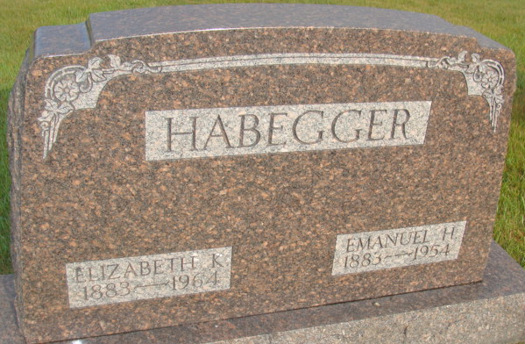
Photo by: Alicia Kneuss

Widow of E. H. Habegger Dies Late Wednesday
Funeral Here Saturday for Local Woman, 80

Mrs. Elizabeth K. Habegger, 80, widow of Emanuel H. Habegger, died at 8:10 p.m. Wednesday at the Adams County Memorial Hospital where she had been a patient for two days. She had been ill the past year, bedfast at home much of the time and death is attributed to a series of strokes.
Mrs. Habegger lived on California Street in the southeast part of Berne, with her only son, Lester R. Habegger and family. She was a lifelong resident of the community and attended the First Missionary Church.
Mrs. Habegger was born in Wabash Township, April 28, 1883, a daughter of Jacob and Katherine Neuenschwander Amstutz. She was married to Mr. Habegger April 6, 1918 at the First Missionary church here. He preceded in death in 1954.
Surviving in addition to the son are six grandchildren. Four brothers and two sisters preceded in death.
Services will be held at 10 a.m. Saturday at the First Missionary Church, Rev. C. H. W??? officiating. Burial will be in the M.R.E. Cemetery. The body is at the Yager Funeral Home where friends may call until 8:30 a.m. Saturday when it will be removed to the church. (Friday, April 3, 1964)

Berne Library Heritage Room, Adams County, Indiana
Adams County Obit Book 1962-1964

