Elizabeth (Lehman) Habegger
September 10, 1864 – August 9, 1910

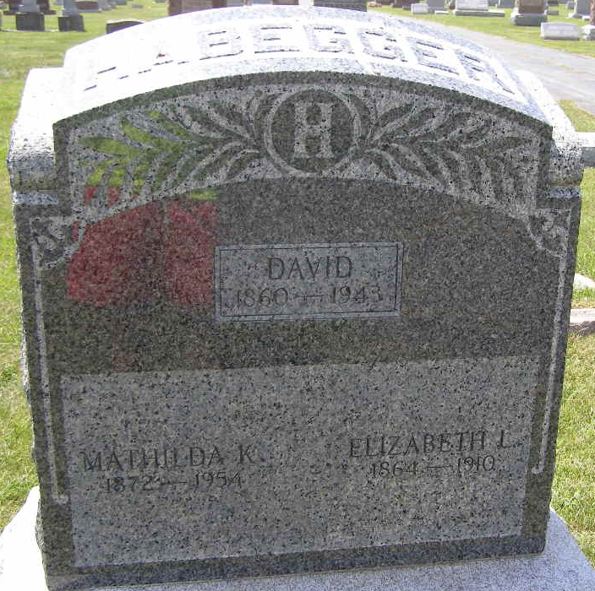
Photo by: Shaunda Bedwell

MRS. ELIZABETH HABEGGER

Mrs. David Habegger, nee Elizabeth Lehman, living two miles northeast of Berne, died very suddenly Tuesday morning early, of heart failure. Mrs. Habegger was at times suffering attacks of weakness of the heart, though never very seriously, and enjoyed fairly good health until her sudden demise, which came as a shock to all who knew her, and the sympathy of the entire community goes out to the sorely bereaved family consisting of the widowed husband and 8 orphaned children, some of them quite small.
The deceased was born and reared on the old Abraham Lehman homestead, now composing the southwestern portion of the town of Berne, on September 10, 1864. In September, 1890, she gave her hand in holy wedlock to David Habegger and henceforth shared with him the joys and trials of life on the old Habegger homestead. Nine children cheered their home, of whom one preceded the mother.
She died in the prime of womanhood, aged 45 years, 10 months and 29 days. Besides these and her husband four brothers and two sisters mourn her early departure.
Funeral services take place this forenoon at 9 o’clock from the Mennonite church, of which she has been a faithful member since her youth.

*****
Indiana, U.S., Death Certificates, 1899-2011
Name: Elizabeth Habegger
[Elizabeth Schman]
Gender: Female
Race: White
Age: 45 years, 10 months, 29 days
Marital status: Married
Birth Date: 10 Sept. 1864
Birth Place: Adams Co
Death Date: 9 Aug 1910
Death Place: Monroe, Adams, Indiana, USA
Father: Abraham Lehman
Mother: Barbra Zuercher
Spouse: David Habegger
Informant: David Habegger; Berne, Indiana
Burial: August 12, 1910; MRE Cemetery

