Frank Habegger
December 4, 1893 – August 6, 1971

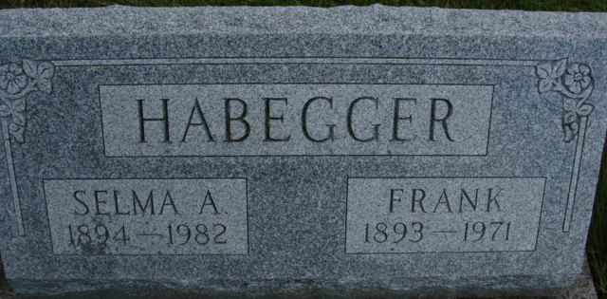
Photo by Alicia Kneuss

Habegger Rites Held on Sunday

Services were held at the First Mennonite Church Sunday afternoon for Frank Habegger, 77, lifelong resident of this community, who died unexpectedly at 11:30 am Friday at the Adams County Memorial Hospital. Burial was in the MRE Cemetery.
Mr. Habegger, a resident of Swiss Village the past six months, was ill since August 1, but had been in failing health for several years. He was admitted to the hospital Friday morning, six hours before his fatal attack.
He was a retired farmer and carpenter and during the past few years, until slowed by ill health, he worked for his sons, Sam and Charles in the operation of Habegger Builders. He and his family lived on a farm northeast of Berne for many years and before moving to Swiss Village, he and Mrs. Habegger resided on West Main Street.
Mr. Habegger was born in Monroe Township December 4, 1893, a son of David and Elizabeth Lehman Habegger. He was married to Selma Neuenschwander September 2, 1917. She survives.
Also surviving are four sons, Dr. James E. Habegger, Geneva, Illinois; Dr. Elmer D. Habegger, Indianapolis; Samuel C. and Charles E., both of Berne; three daughters, Mary Ann J. Habegger, a missionary at Bozoum, Africa; Mrs. Eugene (Virginia) Spencer, Morton Grove, Illinois and Mrs. John (Elaine) Colsten, Munster, Indiana; 21 grandchildren and three sisters, Mrs. Arthur (Ella) Rosenberger, Bluffton, Ohio; Mrs. Ralph (Elizabeth Blosser) North Canton, Ohio and Mrs. William (Victoria) Wells, Lima, Ohio.
A son, Arthur, died in infancy and two brothers, Alfred and Amos, three sisters, Metta, Mary Ann and Cora and one sister in infancy are deceased.
Mr. Habegger was a member of the First Mennonite Church.

Berne Library Heritage Room, Adams County, Indiana
MRE Obit Book 1966-1972

