Menno Burkhart Habegger
April 28, 1891 – May 20, 1967

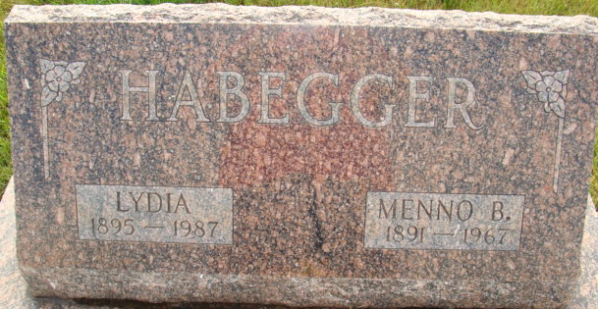
Photo by Alicia Kneuss

Hardware Store Owner for Many Years, Dies Saturday

Mr. Habegger, long a prominent businessman in Berne, died at the Cooper Rest Home, Bluffton, where he was a patient for nearly five weeks. He had been ill three years, being afflicted with arterio sclerosis and had been in a serious condition for many months. Last fall he was hospitalized for four weeks.
He was a partner in the Serv-Us-Store here from the time it was started in 1934 by Mr. Habegger, the late David D. Lehman and the present owner, Eventt Lehman. Mr. Habegger sold out his share to Eventt Lehman in September of 1962. Before starting the Serv-Us-Store, Mr. Habegger was employed by the Berne Hardware Company, earlier by Lehman Brothers Hardware and in his early years was in the employ of the late Dr. Amos Reusser.
A lifelong resident of this community, Mr. Habegger was a member for many years and a former officer of the Berne Chamber of Commerce. He was a member of the First Mennonite Church.
He was born in Monroe Township April 28, 1891, a son of Abraham M. and Lena Moser Habegger. He was married July 13, 1913, in Berne to Lydia Lehman, who survives.
Also surviving are two sons, Lester G. Habegger, Fort Wayne and Max D. Habegger, Houston, Texas; two daughters, Mrs. Chris (Harriett L.) Gerber, LaPorte and Mrs. Deryll (Marjorie M.) Sprunger, Bluffton; 10 grandchildren and three great-grandchildren.
Mr. Habegger was the last member of his family. Six brothers and two sisters preceded in death. They were Samuel, Jacob, Abraham, Eli, Robert, Peter, Mrs. Adam Neuenschwander and Mrs. Benhart Lehman.

Berne Heritage Room, Adams County, Indiana
MRE Obits 1966 – 1972

