Lee Stanley Haines
1933 – October 4, 1969
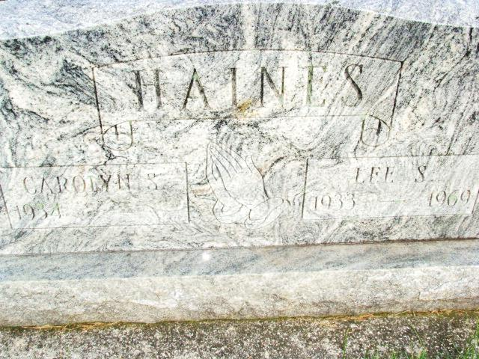
Photo by Alicia Kneuss
Lee Stanley Haines
Date of Death: October 4, 1969; Date of Burial: October 6, 1969
Burial: S ½ Section One, 5th Addition

Traffic Mishap Kills Lee S. Haines

A widely known Geneva man Saturday morning became Adams County’s eighth traffic victim of 1969.
Funeral services were held at 10:30 am today at the Hardy and Hardy Funeral Home in Geneva for Lee Stanley Haines, 36, the Saturday morning victim. The Rev. Virgil Taylor, pastor of the Geneva United Methodist Church officiated and burial was in the MRE Cemetery west of Berne. The casket was not open.
Adams County has had four traffic fatalities in the past two weeks. Two weeks ago Saturday, Oscar J. Miller of R.R. 4, Decatur, was the victim. A week ago Saturday, two Bellmont High School athletes, both residents of the Preble Community, were killed in the same wreck.
The 1968 traffic toll in Adams County was 11.
Mr. Haines, the father of six children, died almost instantly in a two vehicle collision 150 feet north of the Geneva School before he could be released. Persons on the scene soon after the crash said Haines appeared to take a few breaths then died without regaining consciousness. His head was badly crushed. According to Adams County Coroner Richard Linn, death was attributed to massive head, chest and internal injuries. The steering wheel of his vehicle was badly bent and the left front part of the station wagon was almost missing. Both vehicles were demolished.
The investigation into the wreck is being continued but it is likely the fog played an important role. The impact of the crash was heard over a wide area and several people in the neighborhood rushed to the scene. Mrs. Haines was among the early arrivals at the site of the crash and saw her husband pinned in the wreckage. The Detroit couple was headed for Mississippi, authorities said.
Haines was a graduate of Geneva High School with the Class of 1951. While in high school, he starred in baseball and basketball. In 1966, he and Tom Dull organized the South Adams Lancers and Haines had played first base for the Lancers since then and served as coach and co-manager.

Berne (IN) Library Heritage Room
MRE Obits 1969 – 1972
Transcribed by Jim Cox

