Charles O. Hawbaker
February 2, 1886 – June 4, 1968
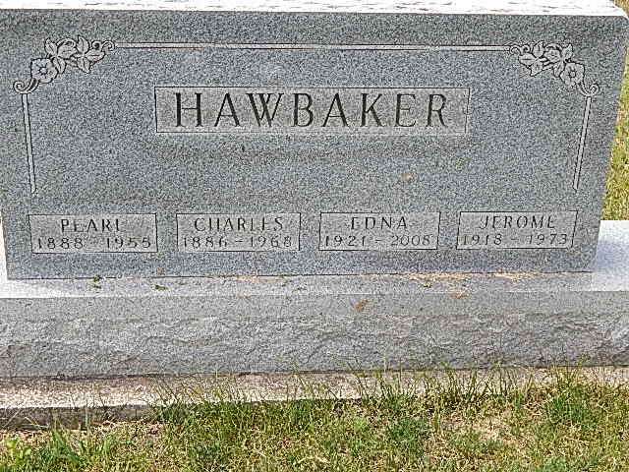
Photo by Alicia Kneuss

Charles O. Hawbaker
Date of Death 1968
Date of Burial: June 7, 1968
Burial: Lot 548 – Original Platt

C. O. Hawbaker Dies Tuesday at Age of 82
Funeral Here Friday for Retired Farmer

Charles O. Hawbaker, 82, Geneva R.R. 1, a retired Wabash Township farmer, died at 12:15 pm Tuesday at the Clinic Hospital in Bluffton. He had been ill the past week and was bedfast four days. He was admitted to the Clinic Hospital Monday evening.
He was born in Wabash Township February 2, 1886, a son of Daniel D. and Caroline Schaffter Hawbaker. He was married to Pearl Moeschberger December 26, 1908 in Vera Cruz. She preceded in death in 1955.
Surviving are a daughter, Mrs. Clyde (Lola) Gould, Decatur; a son, Jerome Hawbaker, Geneva R.R. 1; 10 grandchildren; two great-grandchildren and a sister, Mrs. Mary Schenbeck, Berne. A son, Walter, preceded in death in 1956 at the age of 44. One sister, Mrs. Leona Donnelly is deceased.
Mr. Hawbaker retired from farming in 1946 when he moved to Berne. After the death of his wife, he moved to the home of his son where he resided since. He was a lifelong resident of this community and a member of the Cross United Church of Christ.
The body is at the Yager Funeral Home where friends may call after 9:30 am Thursday. Services will be held there at 10:30 am Friday, Rev. Robert L. Hegnauer, pastor of the Cross Church officiating. Burial will be in the MRE Cemetery.
Berne Library (IN) Heritage Room
MRE Obit Book 1966-1972, image 146
Transcribed by Jim Cox

