Evelyn Jane (Moser) Hawkins
May 12, 1925 – December 29, 1962

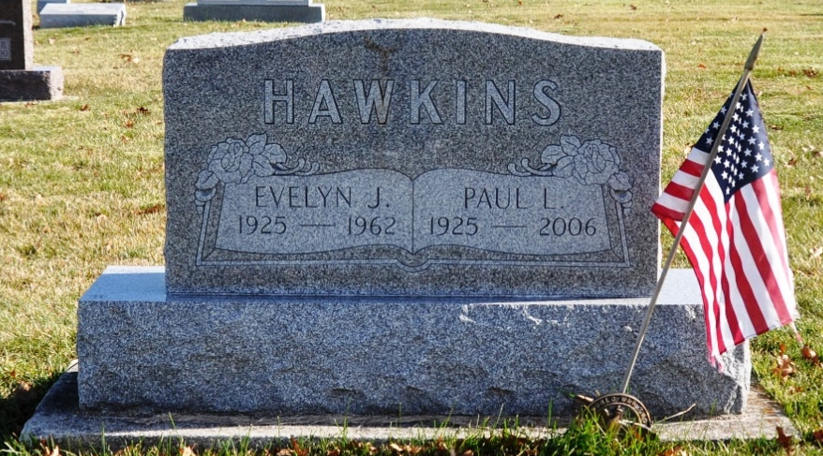
Photo by Deb Curry

Mrs. Paul Hawkins Dies This Morning

Mrs. Evelyn Hawkins, 37, wife of Paul Hawkins, died at 4:10 o’clock this morning at her home, 721 South Hendricks, Berne, following a year’s illness of a bone tumor.
She was born in French township May 12, 1925, a daughter of Edwin E. and Orpha Winteregg-Moser, and was a lifelong resident of the Berne area. She was married July 3, 1947, to Paul Hawkins, former Decatur resident. Mrs. Hawkins was a member of the West Missionary church at Berne.
Surviving are her husband; her parents, also of Berne; one daughter, Sondra Kay Hawkins, at home; three brothers, the Rev. Dale Moser of Hula Vista, Calif.; James Moser of Fremont, and Leroy J. Moser of Berne, and one sister, Mrs. Walter (Joan) Graber of Fort Wayne.
Funeral services will be conducted at 2 p.m. Monday at the West Missionary church, the Rev. Armin C. Steiner officiating. Burial will be in the MRE cemetery. Friends may call at the Yager funeral home after 11 a.m. Sunday until time of the services. (Sat. Dec. 29, 1962)

Berne (IN) Library Heritage Room
Adams County Obits 1962-64

