Francelia A. Jacobs
1855 – September 2, 1940

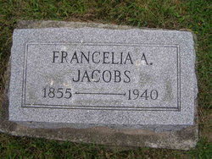
Photo by Alicia Kneuss

MRS. JACOBS, 84, DIES OF BURNS
Berne Woman Pours Kerosene in Stove
Berne, Sept. 2 –
Mrs. Francella Jacobs, 84, died here today at 5:30 pm as the result of burns received when she poured kerosene in a kitchen stove at her residence this morning.
Her daughter-in-law, Mrs. Dow Jacobs, with whom she resided, extinguished the flames of her clothing by wrapping a comforter around the aged victim. The younger Mrs. Jacobs, who received minor burns, was also able to extinguish the small fire which was started in the kitchen.
The aged woman had been a resident of Berne for more than 40 years. Besides the daughter-in-law, she is survived by a number of nieces and nephews, including two that reside in this section, Mrs. Carol Moses of Fort Wayne and Rev. Noah Smith of Angola.
Funeral services will be held Wednesday at 2 pm at the Evangelical Mennonite Church with burial at MRE Cemetery.
Journal-Gazette, Allen County, Indiana
September 3, 1940

