Sarah (Gilliom) Liechty
September 28, 1878 – February 15, 1974

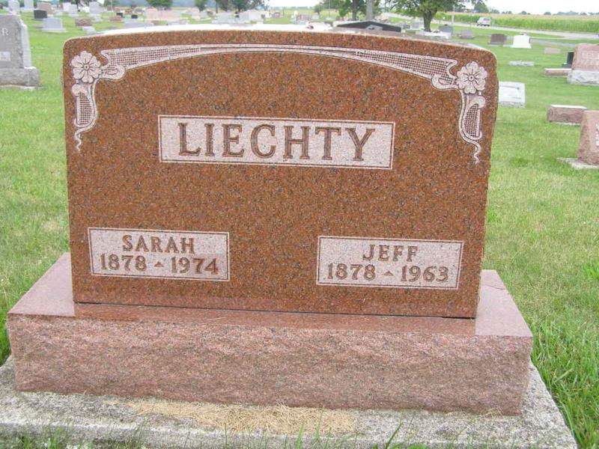
Photo by Shaundra Bedwell

WIDOW OF JEFF LIECHTY DIES AT SWISS VILLAGE

Mrs. Sarah Liechty, 98, one of the area’s eldest children, died at 7:23 Friday in the nursing care unit of Swiss Village after an illness of several days. She had resided at Swiss Village ?? years.
Mrs. Liechty was the widow of Jeff Liechty, long time auctioneer and former treasurer of Adams County. She was a lifelong resident of this community.
Mrs. Liechty was born in Wabash Township, Sept. 28, 1878 the daughter of Christian C. and Mary Lehman Gilliom. She married to Jeff Liechty in Berne, October 30, 1896. Mr. Liechty died a number of years ago.
Surviving are five daughters, Mrs. Otis (Esther) McCoy, Churubusco; Mrs. Howard (Florence) Lehman and Mrs. Agnes Reichard, Berne; Mrs. … (Edith) Gotschalk, Arlington, Virginia and Mrs. Edison (Bernice) Lehman, R.R.2, Berne; a son, Clarence Liechty, South Bend; 17 grandchildren and 40 great-grandchildren; two sisters, Mrs. Tillman (Clara) Fleckiger, and Mrs. Elma Laisure, Warren, Indiana and two brothers, Clifton and … Gilliom, Berne.
Two sisters preceded in death.
Mrs. Liechty was a member of the First Mennonite church where services will be held at 2 p.m. Tuesday. Rev. Sprunger will officiate and burial will be in the M.R.E. Cemetery. Friends may call at the funeral home.

Berne Library Heritage Room
MRE Obits 1973-1984

