Virgil B. Macy
March 3, 1903 – November 28, 1966

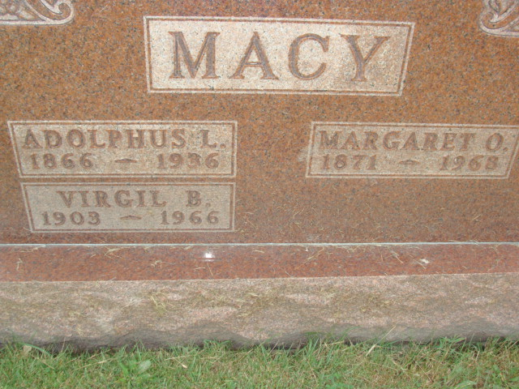
Photo by Alicia Kneuss

Virgil B. Macy
Source:
Berne (IN) Library Heritage Room
MRE Obits 1966‐1972
Transcribed by Jim Cox

Date of Death: November 28, 1966
Date of Burial: December 1, 1966
Burial: Lot 581 Original Platt

Virgil B. Macy, 63, is taken by death

Virgil B. Macy, 63, of Celina, O., route 1, a native of Adams County, died at 11:45 pm Monday at Our Lady of Mercy Hospital at Coldwater, O., following an illness of one and one‐half years.
He was employed as a machinist at the New Idea in Coldwater.
Born in Adams County, March 3, 1903, he was a son of Dulphus and Margaret Jack‐Macy, and was married to Charlotte Dock in 1960.
Mr. Macy was a member of the Moose Lodge at Portland.
Surviving are his wife; a step‐daughter, Charlotte Dock, at home; his mother, Mrs. Margaret Wechter of Decatur, and one sister, Mrs. Eugene Wechter of Los Angeles, Calif.
Funeral services will be held at 2 pm Thursday at the Vale Stein Funeral Home at Celina, with the Rev. William C. Feller, Decatur, officiating. Burial will be in MRE Cemetery at Berne. Friends may call at the funeral home.

