Margaret O. (Jack) Macy-Wechter
October 24, 1871 – July, 1968
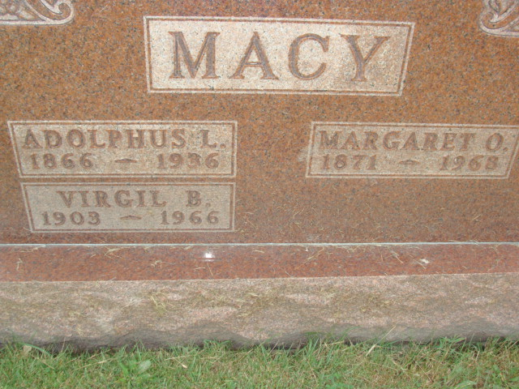
Photo by Alicia Kneuss
Mary (Grandma) Wechter
Source:
Berne (IN) Library Heritage Room
MRE Obits 1967 – 1969, Image 158
Transcribed by Jim Cox

Date of Death: 1968
Date of Burial: July 24, 1968
Burial: 389 Original Platt

Widow of Frank Wechter Dies Today

Mrs. Mary (Grandma) Wechter, 96, of 804 Winchester Street, Decatur, died at 9:20 am today at the Berne Nursing Home where she had been a resident since last November. Death is attributed to infirmities.
She was born in Monroe Township, October 24, 1871, a daughter of Newton and Sarah Ann Ellen Jack. She was married to Adolphus Macy in 1892 and he died June 2, 1936. On December 2, 1937, she married Frank Wechter and he preceded in death on July 8, 1942.
Surviving are a daughter, Mrs. Eugene (Evelyn) Wechter, Speed, Indiana; a step-daughter, Mrs. C. A. (Ethel) Teeter, Geneva R.R. 2; and a foster daughter, Mrs. Thomas (Nellie) Rawley, Berne. Mrs. Wechter was the last survivor of her family.
Mrs. Wechter was a member of the Zion United Church of Christ in Decatur. The body is at the Zwick Funeral Home in Decatur where friends may call after 2 pm Tuesday and where services will be held at 10 am Wednesday. Rev. William C. Feller will officiate and burial will be in the MRE Cemetery.

