Peter J. Mazelin
July 2, 1913 – July 28, 1995

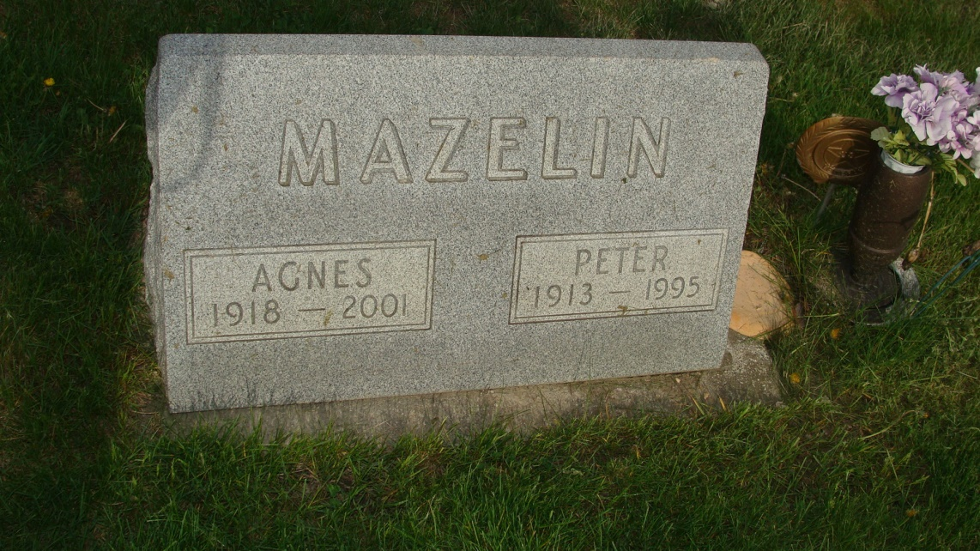
Photo by Alicia Kneuss

Peter J. Mazelin, 82, 1801 Greencroft Blvd., Apt 239, Goshen, IN died 5:25 pm Thursday, July 28, 1995 at the Greencroft Health Care Center, Goshen, IN. He had been ill the last 17 days. He was born in Kidron, OH July 2, 1913 and married Agnes A. Habegger in Berne on June 18, 1939.
A member of the Prince of Peace Lutheran Church, Mr. Mazelin had lived in Goshen since June, 1989, having moved to Goshen from Sebring, Florida where he had resided from 1979 to 1989. He was Hatchery Manager at Neuhauser Hatcheries, Inc., having retired in 1978 after 31 years there.
Surviving are two sons, Gene S. Mazelin, Bangor, MI and Kerry L. Mazelin, Midland, MI; 4 grandchildren; 2 brothers, Rufus Mazelin, Scottsville, KY and Frank Mazelin, Clarksdale, MS; and 3 sisters, Mrs. Martha Schrock and Mrs. Maryann Hoover, both of Scottsville, KY and Mrs. Lina Mazelin, Fayetteville, TN. He was preceded in death by 1 son, Teddy Wayne Mazelin, September 27, 1941; 2 brothers, Allen and Silas and 2 sisters, Sarah Mazelin and Elda Habegger.
Services are 10 am Monday, July 31, 1995 at the Yoder-Culp Funeral Home, 1911 South Main Street, Goshen, IN. Rev. Edward May will officiate and burial will be in the MRE Cemetery, Berne, IN.
Berne Library Heritage Room
Misc. Death Book
(no date provided)

