Raymond Mertz
February 27 1904 – July 9, 1969
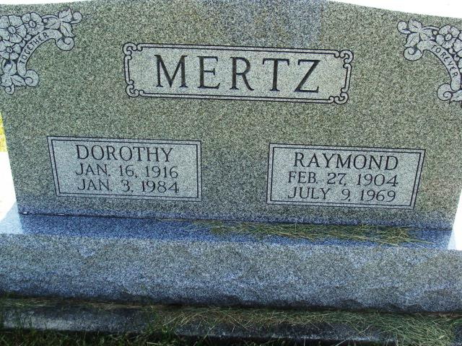
Photo by Alicia Kneuss

Raymond Mertz
Date of Death: July 9, 1969; Date of Burial: July 12, 1969
Burial: N ½ 2, Sect. 1, 5th Add

Raymond Mertz Dies Suddenly on Wednesday

Raymond Mertz, 65, veteran retired employee of the Central Soya Company died suddenly at 1:154 pm Wednesday at his home on Decatur Route 5.
Mr. Mertz had been employed at Central Soya for 34 years before his retirement in 1966.
He was born in Adams County February 27, 1904, a son of Andrew and Elizabeth Amstutz-Mertz, and was married to Dorothy Hakes Simons December 14, 1940.
He was a member of the West Missionary Church at Berne.
Surviving are his wife; a son, Dennis Ray Mertz of Fort Wayne; a daughter, Mrs. Jack (Ellenora) Kostielney of El Paso, Texas; a stepson, Gary Simmons of Decatur; a stepdaughter, Mrs. Don (Bonnie) Walters of Fort Wayne; one sister, Mrs. Martin (Cora) Sprunger of Decatur; and 10 grandchildren. One brother and two sisters are deceased.
Funeral services will be conducted at 10:30 am Saturday at the St. Mark’s United Methodist Church, with Rev. Fuhrman Miller officiating. Burial will be in MRE Cemetery at Berne.
Friends may call at the Zwick Funeral Home until 8:30 am Saturday. The body will lie in state at the church from 9:30 am Saturday until time of the services.

Berne (IN) Library Heritage Room
MRE Obits 1969 – 1972
Transcribed by Jim Cox

