David D. Mettler
December 12, 1869 – October 31, 1963

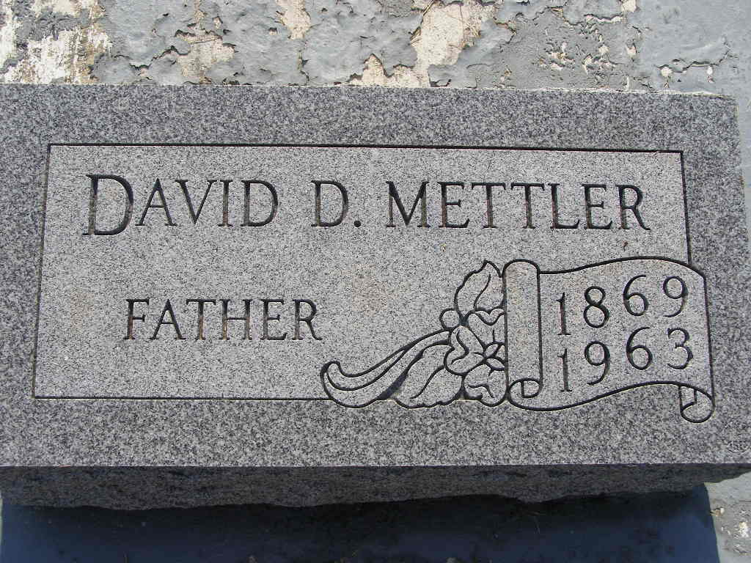
Photo by sillygirl7
94-Year-Old Berne Man Dies Thursday
David Mettler, 94, former maintenance man at the Dunbar Furniture Co. at Berne, died at 6:40 p.m. Thursday at the Lehman rest home in Berne. Surviving are one son, three daughters, 11 grandchildren, 18 great-grandchildren, and one brother.
Services will be held at 2 p.m. Sunday at the Berne United Church of Christ, with burial in MRE cemetery. Friends may call at the Yager funeral home after 7 p.m. today. (Fri. Nov. 1, 1963)

Berne (IN) Library Heritage Room
Adams County Obits 1962-1964
Transcribed by Janice Vasilovski

