Kathryn M. Moore
January 13, 1929 - March 24, 2017

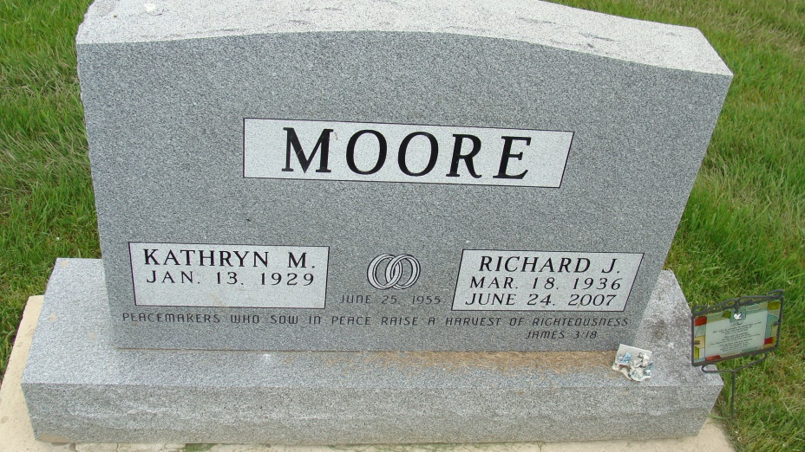
Photo by Alicia Kneuss
Kathryn M. Moore, 88, Berne, passed away on March 24, 2017 at Swiss Village where she was a resident. She was born to George and Eliza Smith Hansen on January 13, 1929 in St, Joe County, In. She married Richard Moore on June 25, 1955.
Kathryn was a member of the First Missionary Church where she was a Sunday School teacher. She retired from EPC in Geneva as a quality inspecter. Her interested included: reading, card playing, enjoying sports and rooting for the Chicago Cubs.
Survivors include: sons, Stephen (Cindy) Moof of Berne, Daniel (Beth) Moore of Frisco, TX., Janis (Jerroll) Lehman of Ft. Wayne, Robyn Moore from Africa, Kelli Moore of Berne, 7 grandchildren, Emily (Nick) Kaeser, Geoff Moore, Jedrienne (Jonathan) Crist, Jacueline (Phillip) Wittwerm, Rachel Moore, Jacen (Megan) Lehman, Jonathan Moore, great-grandchildren, Alexis Crist, Kamren Crist, Presleigh Mae Moore, Elliot Wittwer, Haven Fisher, Emma Rae Crist, Sawyer Lehman, Evan Wittwer, sisters; Betty Brown of Elkhart, Grace Spake of Elkhart, and Ruth Overhulser of Osceola, IN
Preceding in death are; her parents, husband ('07), and sister, Alta Lou Weaver.
Funeral services are Tuesday, March 28 at 10 am at the Swiss Village Auditorium with visitation 1 hour prior to services. Visitation also Monday, March 27 from 2 to 8 pm. at the Village; Officiating is Pastor James Schwartz. Burial is in the MRE Cemetery, Berne.
Preferred memorials are to Robyn Moore Ministry, World Gospel Mission.
Yager-Kirchhofer Funeral Home online obit (accessed 03/25/2017)

