Irene (Badertscher) Morand
November 17, 1894 – January 4, 1968
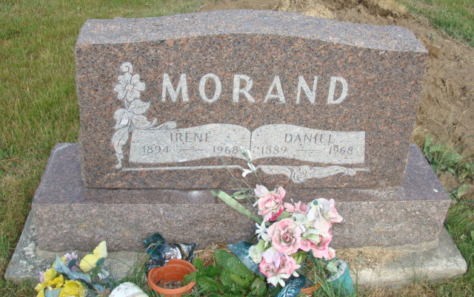
Photo by Alicia Kneuss
Irene Morand
Date of Death: 1968
Date of Burial: January 6, 1968
Burial: N ½ 23, Sect. 2 – 4th Add

Wife of Daniel Morand Dies Early Thursday
Funeral Here Saturday for Local Woman, 73

Mrs. Irene Morand, 73, wife of Daniel Morand of this city, died at 6:50 am Thursday at the Adams County Memorial Hospital where she had been a patient 12 days. She had been in failing health for some time, suffering from a heart ailment and complications. She had been given oxygen the past few days.
Mrs. Morand was a resident of Berne for 50 years and resided along the Parr Road in the north part of the city, on Berne R.R. 1. She was born at Pandora, Ohio, November 17, 1894, a daughter of John and Barbara Elizabeth Amstutz Badertscher. She was married 50 years ago last Saturday, on December 30, 1917 to Daniel Morand.
Surviving are the husband; a son, Lawrence Morand, Dallas, Texaas; two daughters, Mrs. Lenard (Agnes) Johnston, Monroe and Mrs. Donald (Lena) Moore, Berne; eight grandchildren; three great-grandchildren; three half-brothers, Lewellyn, Ivan and Thomas Badertscher, all of Kidron, Ohio and three half-sisters, Mrs. H. Claire (Florence) Amstutz, Goshen; Mrs. Charles (Huldah) Graves, Cleveland, Ohio and Mrs. Howard (Martha) Klett, Canton, Ohio. A son in infancy, a brother, a half-brother, and two half-sisters preceded in death.
Mrs. Morand was a member of the First Mennonite Church.
Services will be held at 1 pm Saturday at the Yager Funeral Home, Rev. Gordon J. Neuenschwander and Rev. Gerald Stucky officiating. Burial will be in the MRE Cemetery.
Friends may call at the Yager Funeral Home.
Berne (IN) Library Heritage Room MRE Obit Book 1966-1972
Transcribed by Jim Cox

