Edwin E. Moser
July 23, 1896 – February 6, 1968
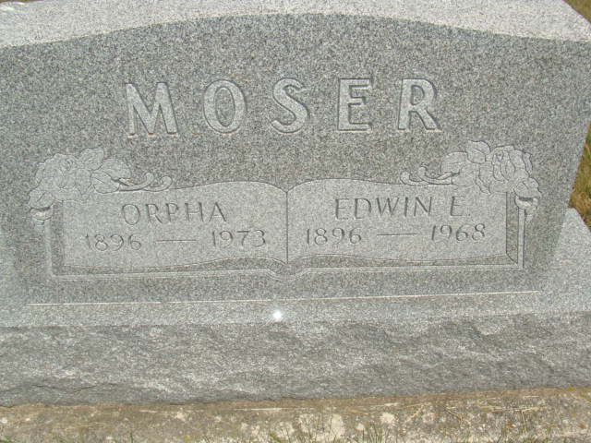
Photo by Alicia Kneuss

Edwin E. Moser
Date of Death: 1968
Date of Burial: February 10, 1968
Burial: N ½ Lot 29, Sec. 1, 4th Addition

Funeral Here Saturday for Edwin E. Moser
Former Berne Man Dies in Phoenix, Arizona on Tuesday

Edwin E. Moser, 71, a former resident of Berne and community, died at 10 am Tuesday, February 6, in a hospital in Phoenix, Arizona. Mr. and Mrs. Moser left Berne in the fall of 1965 and resided in Phoenix since.
Mr. Moser had been seriously ill since November of 1967. He suffered a stroke a year ago last October, but he was able to be up and around part time until last May. He had been bedfast for several months and was critical for several weeks. The immediate cause of death is given as heart failure.
Mr. Moser was a retired farmer and after leaving the farm, he was employed at the Dunbar Furniture Company of this city for 15 years. He spent all of his life in this community until moving to Arizona.
He was born in French Township July 23, 1896, a son of Peter N. and Katie C. Stucky Moser. He was married to Orpha Winteregg on May 17, 1919.
Mr. Moser was a member of the West Missionary Church and was active in the work of the church for many years. He served on the church council and held the offices of trustee, treasurer and missionary treasurer.
Surviving are the wife; three sons, Dale E. Moser, Chula Vista, Calif.; James E. Moser, Fremont, Indiana and Leroy J. Moser, Berne; a daughter Mrs. Walter (Joan) Graber, Phoenix, Arizona; 13 grandchildren and two brothers, Raymond E. Moser and Palmer S. Moser, both of Berne. A daughter, Mrs. Paul (Evelyn) Hawkins, two brothers, Henry and Chester Moser and a sister, Mrs. Edna Kensinger preceded in death.
Berne Library Heritage Room
MRE Obit Book 1966-1972, image 128
Transcribed by Jim Cox

