Glenna F. (Sprunger) Moser
September 17, 1927 – December 19, 2017
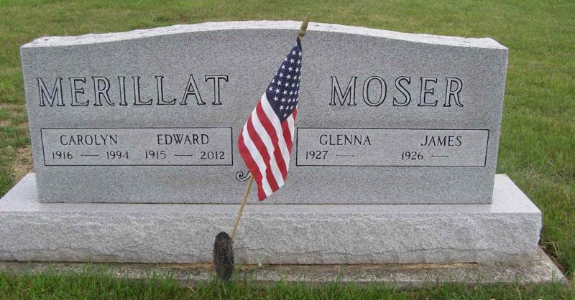
Photo by Shaunda Bedwell

Glenna F. Moser, 90, Berne passed away on December 19, 2017 at Swiss Village where she was a resident. She was born on September 17, 1927 to Herbert and Elma Neuenschwander Sprunger in Adams County, IN. She married James Moser on October 1, 1944.
Glenna was a member of the First Mennonite Church. She was retired as a waitress at the Palmer House Restaurant for over 41 years and sold magazine subscriptions for many years. Glenna was a member of the former Berne Mother's Club and enjoyed reading, cooking, and hosting her family.
Survivors include a daughter, Barbara (Dan) Dawson of Berne, sons; Ted (Judy) Moser of Berne, Gregg (Karen) Moser of Berne, Brian (Kelly) Moser of Linn Grove, 16 grandchildren, 24 great-grandchildren, and 3 step-great grandchildren.
Preceding in death are her parents, (stepmother, Mary (Burkhalter) Sprunger, husband, Jim (1/24/2017), brothers LaVerne, & James Sprunger, sisters Henrietta Nussbaum, and Carolyn Merillet.
Funeral services are Friday, December 22, 2017 at 6:00 pm at the First Mennonite Church with visitation from 4 PM to time of services. Officiating is Pastor Jerry A Flueckiger with burial at the MRE Cemetery, Berne.
Preferred memorials are to the First Mennonite Church Missions &/or Camp Gilead (Children's Bible Mission)

Yager-Kirchhofer Funeral Home online obit (accessed 12/20/2017)

