Prudentia E. (Soldner) Mosser
March 9, 1880 – December 12, 1972
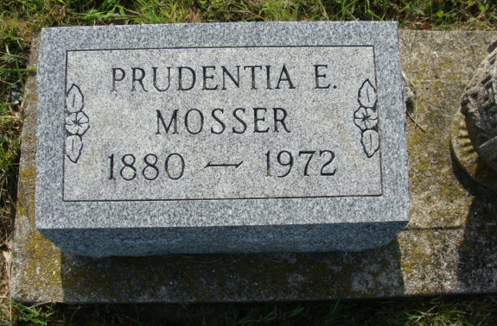
Photo by Alicia Kneuss
Prudentia Mosser
Date of Death: December 12, 1972; Date of Burial: December 14, 1972
Lot 533, Original Platt – MRE Cemetery
Prudentia Mosser Taken by Death
Services will be held at 2 pm Thursday at the Hardy and Hardy Funeral Home in Geneva for Mrs. Prudentia Soldner Mosser, 92, widow of Christian Mosser. Mrs. Mosser died at 8 pm Monday in the Woodland Nursing Home in Muncie. She resided in Geneva before entering the nursing home in Muncie. Burial will be in the MRE Cemetery west of Berne.
Mrs. Mosser was born in Berne March 9, 1880, a daughter of John and Elizabeth Soldner. Her husband died many years ago.
Surviving are two sons, Melvin of Muncie and Lawrence of Indianapolis; a daughter, Mrs. Edith Hurst, Troy, Ohio; two grandchildren; two great-grandchildren and a brother, Noah Soldner, Goshen.
Friends may call at the Hardy & Hardy Funeral Home until time of the service.

Berne (IN) Library Heritage Room
MRE Obit Book 1969-1972
Transcribed by Jim Cox

