Rev. Andrew J. Neuenschwander
November 4, 1888 – April 13, 1972

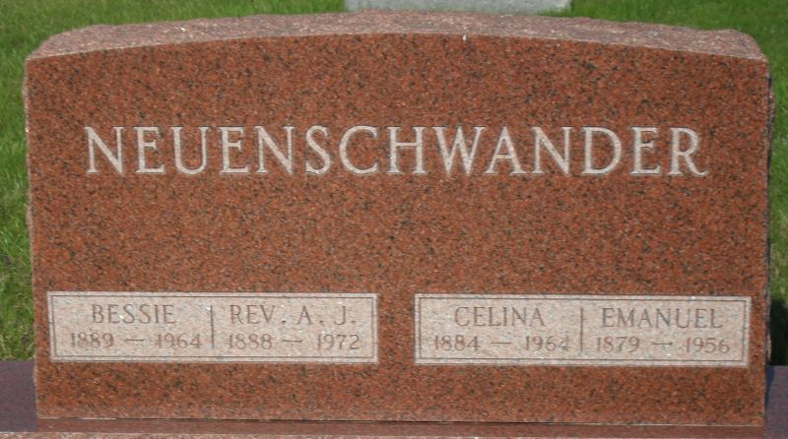
Photo by Stephen & Andrea Brangan

Rites Saturday for Rev. Andrew J. Neuenschwander, 83

The Rev. Andrew J. Neuenschwander, 83, widely known retired pastor and a native of Berne, died at 5:15 pm Wednesday at Lutheran Hospital in Fort Wayne after being hospitalized since February 17. Death was attributed to cardiac failure. He was in the long care section of the hospital.
The Rev. Mr. Neuenschwander, for many years a pastor in the General Conference Mennonite Church, had been in failing health for several months. Before entering the hospital, he was a resident of Swiss Village and plans had been made for him to return to the Village on his release from the hospital.
The Rev. Mr. Neuenschwander returned to Berne in 1965 after being gone from the community for many years. During this time he served Mennonite churches in Ohio, Pennsylvania and California. He also served the conference in various other capacities and after returning here, he was minister to the elderly in the local First Mennonite Congregation for four years.
Rev. Neuenschwander graduated from Berne High School in 1911, and then attended Normal School at Earlham College, Richmond. Afterwards, he taught one year in French Township and after this enrolled at Bluffton College. Following this he received a call from the Mennonite Collegiate Institute, Gretna, Manitoba to teach and serve as dean of men.
He received his BA degree at Bluffton College in 1916 and then entered Garrett Biblical Seminary, Evanston, Illinois for a 12 week summer term. He received his BD degree from Witmarsum Theological Seminary in 1918 and he then took charge at the Apostolic Mennonite Church at Trenton, Ohio.
He was born in Berne November 4, 1888, a son of Jacob C. and Elizabeth Stauffer Neuenschwander. He was married to Bessie Sprunger, September 2, 1917 at the Mennonite Church here. She preceded in death in 1964.
Surviving are two sons, Dr. Robert S. Neuenschwander, West Covina, California and Gordon E. Neuenschwander, Wexford, Pennsylvania; a daughter, Mrs. Alvin C. (Ruth) Ramseyer, Jr., Smithville, Ohio; 10 grandchildren and several nieces and nephews. Two children preceded in death in infancy. Three brothers, Emmanuel, David and Adam Neuenschwander and two sisters, Mrs. Peter Habegger and Mrs. Edwin Suter are deceased.

Date of Death: April 20, 1972; Date of Burial: April 22, 1972
Burial: MRE

Berne (IN) Library Heritage Room MRE Obit Book 1966-1972
*****
Retired minister dies at hospital

Rev. Andrew J. Neuenschwander, 83, retired Mennonite church minister, and resident of Swiss Village, Berne, died at 5:15 p.m. Wednesday at the Lutheran hospital in Fort Wayne, where he had been a patient since Feb. 17.
He was born in Berne Nov. 4, 1888, a son of Jacob C. and Elizabeth Stauffer-Neuenschwander, and was married to Bessie Sprunger Sept 2, 1917. His wife preceded him in death in 1964.
Rev. Neuenschwander retired from the active ministry in 1965 after serving Mennonite churches in several conferences, and serviced as minister to the elderly for four years after returning to Berne in 1965.
Surviving are two sons, Dr. Robert S. Neuenschwander of West Covina, Calif., and Gordon E. Neuenschwander of Wexford, Pa.; one daughter, Mrs. Alvin (Ruth) Ramseyer, Jr., of Smithville, O.; and 10 grandchildren. Two children died in infancy.
Funeral rites will be held at 2 p.m. Saturday at the First Mennonite church in Berne, with Rev. Gordon J. Neuenschwander officiating. Burial will be in MRE cemetery. Friends may call at the Yager funeral home in Berne after 2 p.m. today. Preferred memorials are to the general conference mission of the Mennonite church, or to the Bluffton College.
Decatur Daily Democrat, Adams County, Indiana
Friday, April 21, 1972

