Cora (Winteregg) Neuenschwander
May 21, 1898 – April 9, 1941

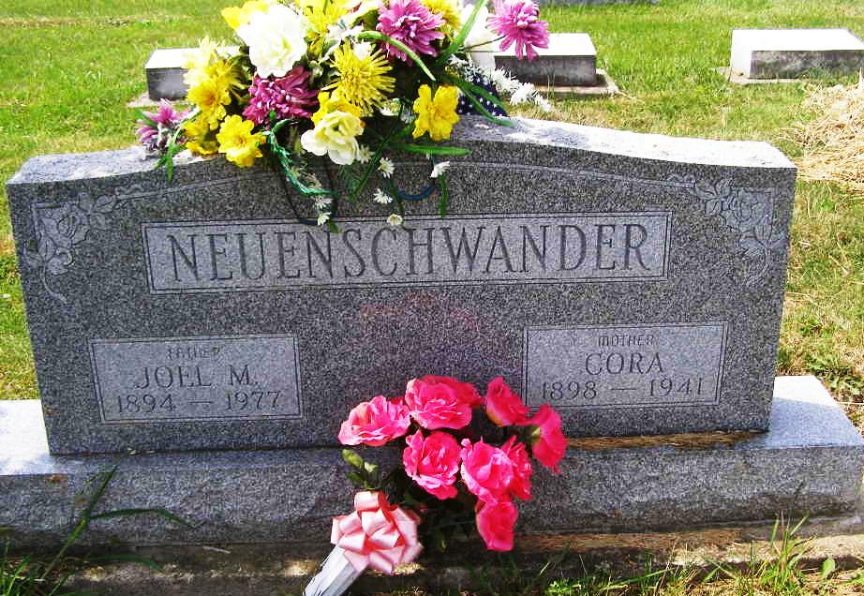
Photo by Shaunda Bedwell

(Handwritten date: Thursday, April 10, 1941)

DIES SUDDENLY LAST EVENING
Mrs. Joel Neuenschwander, Mother of Nine, Dies Suddenly

Mrs. Cora Neuenschwander, 42, wife of Joel Neuenschwander, died suddenly at 10 o'clock Wednesday at her home in Wabash township.
She became ill after retiring and fell over as she attempted to get out of bed. Death was unexpected, although, she had been in failing health for several years.
Mrs. Neuenschwander was born in Monroe township, May 21, 1898, the daughter of David and Louise Baumgartner-Winteregg.
Surviving besides the husband are nine children, all at home: Sherman, Vergene, Florine, Romana, Ellewyne, Willodean, Delmar, Leoris and Marjorie; two brothers, Homer Winteregg of Monroe and Elmer Winteregg of Berne; and two sisters, Mrs. Noah Graber of Berne and Mrs. Eli Graber of French township.
She was a member of the Mennonite church.
Funeral services will be held at the home at 1:00 o'clock Saturday afternoon and at 2 p.m. at the Mennonite church. Burial will be in the M.R.E. cemetery. The body will be taken from the Yager funeral home to the residence and may be viewed after this evening until time of the funeral.
Adams County Historical Museum
1940-1941a Scrapbook, image 48
Transcribed by Karin King

