Omega Ann Neuenschwander
August 24, 1940 – December 25, 1940
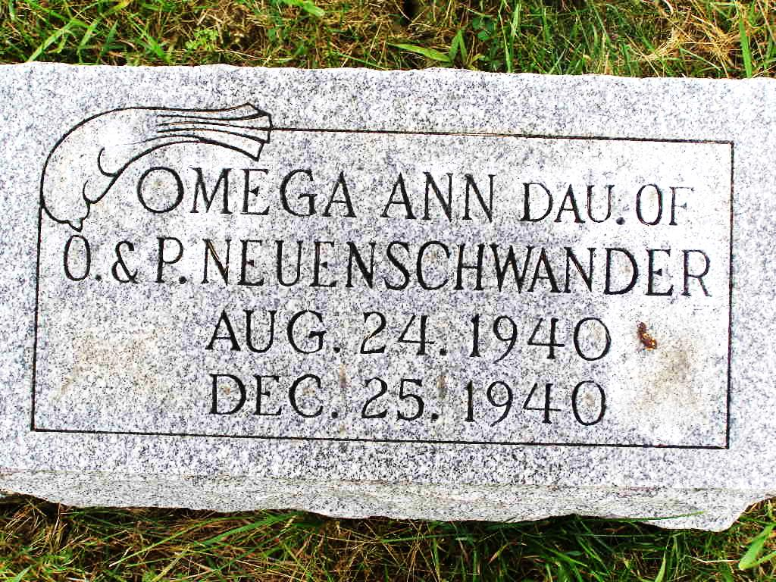
Photo by Shaunda Bedwell

Adams Public Library System (Decatur, IN) online obit abstracts
Publication: Decatur Daily Democrat; Date: 26 DEC 1940
Title: Neuenschwander, Omega Ann
Subject: Obituaries -- N -- 1940-1949
Abstract: Age: Four Months Old - a twin
Daughter of: Orval & Pollyann Lehman Neuenschwander
Notes: ACHS – 65

*****
(Handwritten date: Friday, December 27, 1940)
CARD OF THANKS
We wish to express our appreciation for the beautiful floral gifts and kind expressions of sympathy given us during the bereavement caused by the death of our dear little daughter and granddaughter, Omega Ann.
Mr. and Mrs. Orval Neuenschwander and daughter Chloe Ellen
Mr. and Mrs. Peter B. Lehman and family
Adams County Historical Museum
1940 Scrapbook, image 176-177
Transcribed by Karin King

