Kimberly Sue Nussbaum
April 5, 1981 – February 15, 1993
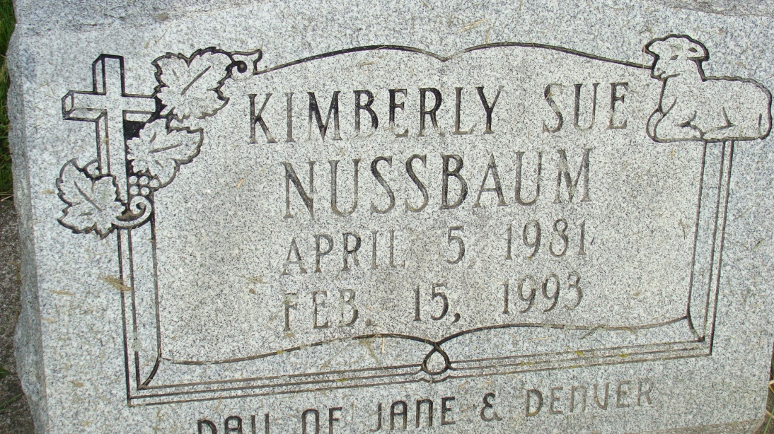
Photo by Alicia Kneuss
Services will be held Friday for Kimberly Sue Nussbaum, 11, Berne, who died Monday from injuries received in an automobile accident in Adams County.
She was born April 5, 1981 in Adams County, the daughter of Denver and Jane Liechty Nussbaum, who survive.
A sixth grade student at South Adams Middle School, she attended the First Mennonite Church. She was a member of the Wabash R-H Club, she participated in gymnastics in the White Water State Games and her special interests were reading and gymnastics.
Surviving in addition to her parents are three sisters, Audrey, Teresa and Lori Nussbaum, and a brother, Bradley Nussbaum, all at home; her grandparents, Mr. and Mrs. Ernie (Berdella) Liechty, Berne and Mr. and Mrs. Reuben (Estella) Nussbaum, Monroe and her great-grandmother, Marie Alt, Berne.
Funeral services will be held Friday at 10:30 am at First Mennonite Church of Berne with the Rev. Robin LaRue and the Rev. Milo Nussbaum officiating. Burial will be in the MRE Cemetery.
Portland Commercial Review, Jay County, IN; February 18, 1993
Contributed by Jim Cox

