Wilbert Nussbaum
October 12, 1889 – January 17, 1963

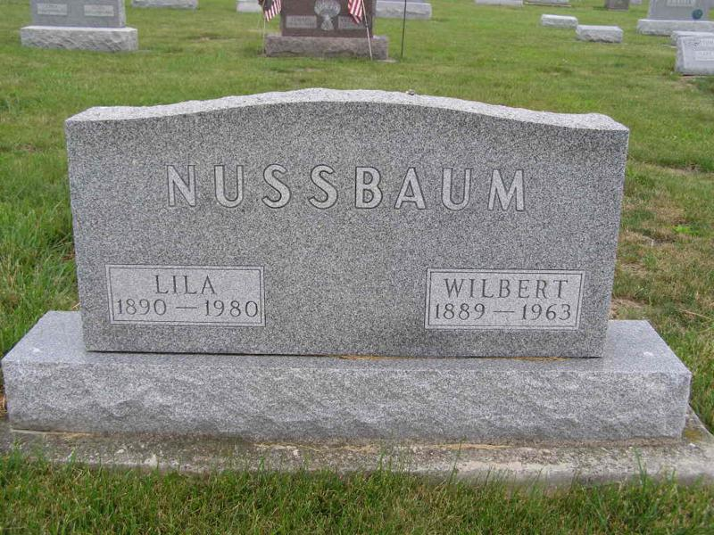
Photo by Shaunda Bedwell

Wilbert Nussbaum Is Taken By Death

Wilbert Nussbaum, 73, prominent Adams county contractor and farmer, and a former trustee of the Adams county memorial hospital, died Thursday morning at the local hospital, where he had been a patient for 13 days.
Mr. Nussbaum was a member of the board of trustee when the addition was completed a few years ago. He had also served as general appraiser for the French Twp. Insurance Co. for many years, and for seven years was deputy assessor in Monroe township.
Born in Monroe township Oct. 12, 1889, he was a son of Benjamin and Elizabeth Riff-Nussbaum, and was married to Lila Sprunger Oct. 19, 1913.
Mr. Nussbaum, a resident of Berne route 1, was a member of the First Mennonite church at Berne.
Surviving in addition to his wife are two sons, Jerome Nussbaum of Berne, and Paul Nussbaum of Berne route 1; three daughters, Mrs. Donald Sprunger, Mrs. Ernest Schwartz and Mrs. Howard Flueckiger, all of Berne; 16 grandchildren; three great-grandchildren; one brother, Harve H. Nussbaum of Berne, and four sisters, Mrs. Simeon Lehman, Mrs. Theodore Sprunger, Mrs. Willie (Wilbur) Luginbill and Mrs. Alfred Lehman, all of Berne.
Funeral services will be conducted at 10 a.m. Saturday at the First Mennonite church, the Rev. Gordon Neuenschwander officiating. Burial will be in MRE cemetery. Friends may call at the Yager funeral home until 9 a.m. Saturday.
(Fri. Jan. 18, 1963)

Berne (IN) Library Heritage Room
Adams County Obits 1962-1964
Transcribed by Janice Vasilovski

