Rosine (Gerber) Oberli
December 8, 1888 – September 1973

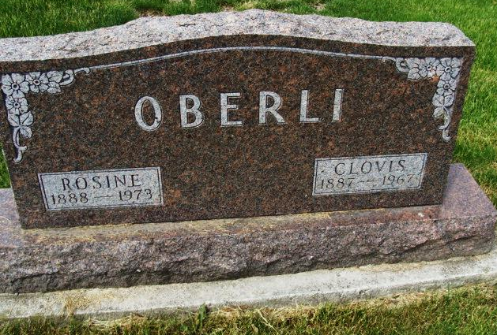
Photo by Alicia Kneuss
Rosina Oberli, 84, dies unexpectedly
Mrs. Rosina Oberli, 84 of Swiss Village, Berne, widow of Clovis Oberli, passed away unexpectedly of an apparent heart attack Wednesday evening while visiting in the home of Menno Eicher at Berne. She was pronounced dead on arrival at Clinic Hospital in Bluffton at 9:15 p.m.
Mrs. Oberli, a native of Switzerland was a member of the First Mennonite Church in Berne. She was born December 8, 1888, at Canton, Bern, Switzerland, the daughter of Abraham and Bertha Lehman-Gerber, who preceded her in death. She was married Jan. 23, 1909 in Switzerland to Clovis Oberli who preceded her in death May 25, 1967.
Survivors include a sister, Mrs. Laura Chappelier of Horse Head, N.Y., and two brothers, Charles Gerber of Paris, France, and Otto Gerber of Canton, Vaud, Switzerland. Two sisters and five brothers preceded her in death.
Funeral services will be conducted at 2 p.m. Friday at the First Mennonite Church Chapel in Berne with the Rev. Kenneth G. Bauman officiating. Burial will follow in MRE cemetery. Friends may call at the Yager funeral home after 6 p.m. today.

Decatur Daily Democrat, Adams County, Indiana
Thursday, Sept. 27, 1973
*****
FUNERAL HERE TODAY FOR MRS. CLOVIS OBERLIN

Mrs. Rosina Oberlin (sic), 84, widow of Clovis Oberlin, was dead on arrival at the Clinic hospital in Bluffton at 9:15 p.m. Wednesday. Death is blamed to a heart attack and was sudden.
A member of the First Mennonite church, Mrs. Oberlin long was prominent in ladies’ activities of the church, Services were held in the church chapel at 2 p.m. today, the pastor, Rev. Kenneth G. Bauman officiating and burial was in the M.R.E. cemetery. The Yager Funeral home had charge of the service.
Mrs. Oberlin, a resident of Swiss Village, had been in the Menno P. Eicher home Tuesday and Wednesday helping in the home during the rush of potato harvest. She has been doing this on her own request, for years. Wednesday evening she complained of not feeling good and members of the Eicher family offered to drive her to the Clinic. She died on the way.
Mrs. Oberlin was born in Canton Berne, Switzerland, December 8, 1888, a daughter of Abraham and Bertha Lehman Gerber. She married Clovis Oberlin in Switzerland January 23, 1909 and they came here the following year in 1910. Mr. Oberlin, long an industrial leader in this community, preceded in death May 25, 1967.
Surviving are two brothers, Charles Gerber, Paris, France and Otto Gerber, Canton Vand, Switzerland and a sister, Mrs. Laura Chappelier, Horse Head, New York.
A brother, Robert Gerber, four other brothers and two sisters preceded in death.

Note: no date, between September-October, 1973

Berne (IN) Library Heritage Room
MRE Obits 1973-1984, image 027

