Nellie G. (Styler) Rawley
October 23, 1862 – October 17, 1971

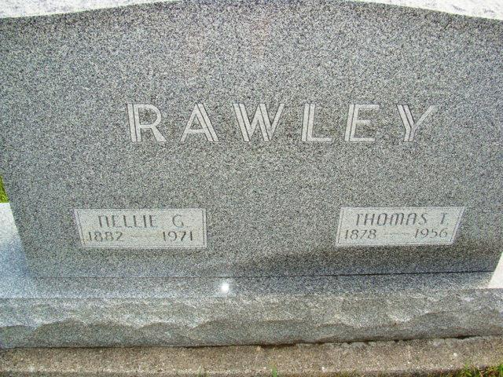
Photo by Alica Kneuss

Date of Death: October 17, 1971; Date of Burial: 1971; Burial: MRE

Mrs. Thomas Rawley Dies Early Sunday
Injuries Received in Fall Cause Fatal Complications

Mrs. Nellie Rawley, 88, widow of Thomas Rawley, died at 4:20 am Sunday in the Adams County Memorial Hospital in Decatur. Death was attributed to complications which developed after Mrs. Rawley received a broken left arm in a fall September 7.
A lifelong resident of this community, Mrs. Rawley had resided with her only daughter, Mrs. Willard Baumgartner in Berne since 1965.
She was a native of Wadsworth, Ohio, where she was born October 23, 1862, a daughter of David F. and Nancy Grace Styler. She was married to Thomas T. Rawley November 27, 1907 in this community. Mr. Rawley preceded in death in 1956.
Surviving are the daughter, Mrs. Willard (Margaret) Baumgartner of Berne; two granddaughters, Mrs. Stanley (Grace) Sprunger and Mrs. Robert (Margaret) Mundy; and two foster sisters, Mrs. C. A. (Ethel) Teeter), R.R. 2, Berne and Mrs. Eugene (Evalyn) Wechter, Speed, Indiana.
Mrs. Rawley was a member of the First Mennonite Church.
The body is at the Yager Funeral Home where services will be held at 10:30 am Tuesday. Rev. Gordon Neuenschwander and Rev. Gerald Stucky will officiate and burial will be in the MRE Cemetery.

Berne (IN) Library Heritage Room
MRE Obit Book 1966-1972
Transcribed by Jim Cox

