Nicholas Rich
December 6, 1867 – May 11, 1935

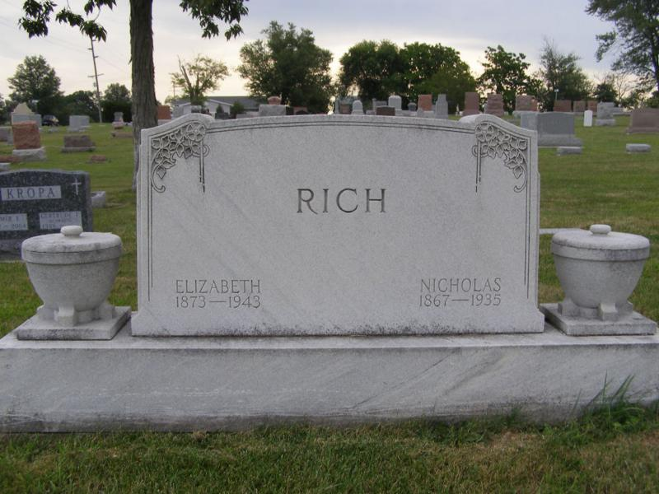
Photo by Shaunda Bedwell

NICHOLAS RICH DIES SATURDAY
Prominent Monroe Township Farmer Dies Saturday Night

Nicholas Rich, 67, prominent farmer of Adams county, died at his home in Monroe township Saturday night at 9:45 o'clock of cancer. He had been bedfast for several weeks.
Mr. Rich had spent his entire life in this county and was a prominent farmer. He was a stockholder and director of the Peoples State Bank.
He was born in French township December 6, 1867, a son of Joseph and Anna Moser-Rich. His marriage to Elizabeth Dailey took place on April 26, 1894.
Surviving are the widow and two children, William Rich and Mrs. Rufus Nussbaum of Monroe township. Two brothers, John Rich of Berne and David Rich of Fort Wayne, and a sister, Mrs. Jonas Myers of Vera Cruz, also survive. One daughter, four brothers and two sisters preceded him in death.
He was a member of the Reformed church at Berne. Funeral services will be held Tuesday afternoon at 1:30 o'clock at the home and at 2 o'clock at the church. Rev. C. W. H. Sauerwein of Plymouth will officiate and burial will be in M. R. E. cemetery.

Decatur Daily Democrat, Adams Co, IN; Monday 13 May 1935

*****
Karin King note: Title, date & beginning of this obit is missing, but it belongs to Nicholas Rich [1867-1935]

...The deceased was born in French township, Dec. 6, 1867, a son of Joseph and Anna Moser Rich. He was born on the old Joseph Rich homestead and at the time of his death was ? years, 5 months and 5 days old. He spent his entire life in this community. Most of his life was spent on the farm, and he was known as one of the leading farmers of Adams county. Mr. Rich was married to Elizabeth Bailey April 26, 1894.
INTERESTED IN BUSINESS
Mr. Rich was a stockholder of the Peoples State Bank here and a former director of the institution. He was also financially interested in other business activities. For two years in his early manhood days he was employed in Berne, clerking at the Allison and Simison store.
Mr. and Mrs. Rich had resided on their present farm for the past eleven years, but lived on another farm just across the road from their home, for a long time.
Surviving are the widow and two children, William and Mrs. Rufus (Ida) Nussbaum, both of northeast of Berne. Two brothers, John of Berne and David of Fort Wayne, and one sister, Mrs. Jonas Myers of Vera Cruz, survive.
His parents, one daughter, Mrs. Edna Beer, and the following brothers and sisters preceded him: Chris, Joseph, Peter, Jacob, Mrs. Barbara Stucky and Mrs. Anna Yoder.
Mr. Rich was a member of the Reformed church and was active in church work. The funeral will be held Tuesday afternoon at 1:30 o'clock at the home and at 2 o'clock at the local Reformed church, Rev. C. W. H. Sauerwein, of Plymouth, formerly of Berne, and Rev. C. H. Suckau, officiating. Burial will be in the M.R.E. cemetery.

Adams County Historical Museum
1935 Scrapbook, image 17
Transcribed by Karin King

