Erma I. (Blocker) Runyon
December 4, 1898 – October 22, 1943
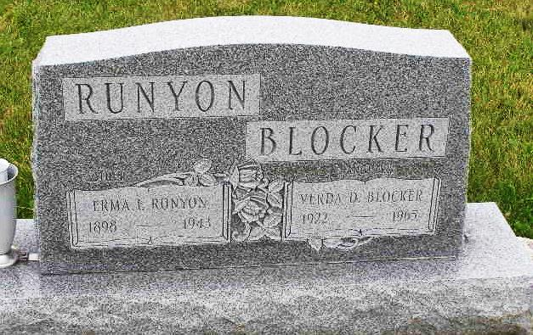
Photo by Shaunda Bedwell

(Handwritten date: Monday, October 25, 1943)

RITES TODAY FOR WABASH TP. LADY
Mrs. James Runyon, 44, Dies Following Operation At County Hospital

Funeral services were held this afternoon at 2:30 o'clock for Mrs. James Runyon, 44, Wabash township woman, who died Friday evening at 6 o'clock at the Adams County Memorial hospital, where she had undergone a major operation a few days ago. She had been ill four weeks; three days she was critically ill.
Rites were held at the Apple Grove church east of Geneva, near where the family resides and of which the deceased was a member. Burial was made in the M.R.E. cemetery west of here. Rev. Delbert Cress was the officiating minister.
The family resides three miles east of Geneva on what is known as the old Beerbower farm.
Prior to her marriage, Mrs. Runyon was Miss Emma Blocher [sic], a daughter of Mrs. G. W. Blocher of Domestic. She was born in Wells county on December 4, 1898.
Surviving besides the husband are two daughters, Mrs. Sol Mosser, Jr., and Miss Verda Blocher [sic]; five brothers, Sterling and Russell Blocher of Domestic, Alvin of Decatur, Harold and Belvin of Massillon, Ohio, and a sister, Mrs. Carrie Blair of Petroleum.

Adams County (IN) Historical Society
1943b Scrapbook, Image 144
Transcribed by Karin King

