Emma Sophia (Mettler) Schindler
May 10, 1878 – August 25, 1911

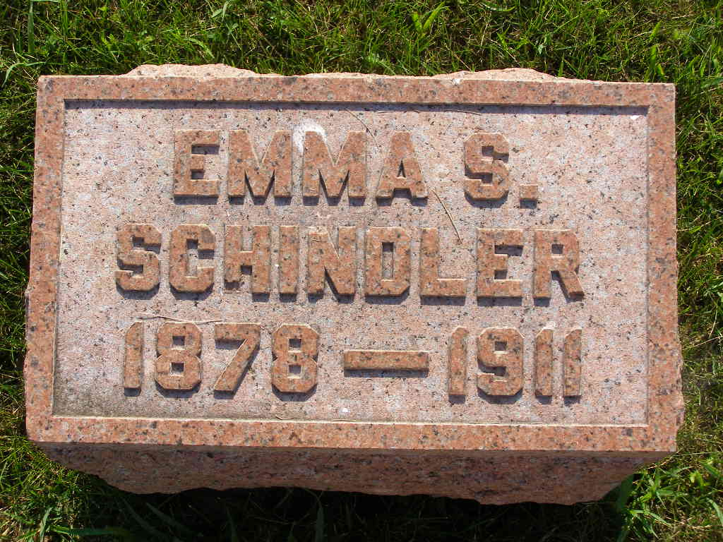
Photo by sillygirl7

Mrs. Reuben Schindler

After a lingering illness of many months with a complication of diseases, Mrs. Reuben Schindler, living about two miles west of Berne, was relieved by death last Friday.
Mrs. Emma Sophia Schindler, nee Mettler, was born in Adams county, May 10, 1878, and died August 25, 1911, aged 33 years, 3 months and 15 days. She received religious instruction under Rev. Ruff and publicly confessed faith in Jesus Christ and was received into full membership of the Reformed church in 1894.
The deceased was married to Reuben Schindler on Feb. 20, 1904, by Rev. E. H. Vornhoft. This union was blessed with three children, two boys and one girl, the oldest only six years old. The deceased was fully reconciled to die, having a living hope of life everlasting she longed for the Master's call.
She leaves, to mourn their bitter loss, her sadly bereaved husband, with the three orphaned children, father, two sisters and two brothers. Her mother, one brother and one sister preceded her in death. The funeral was held yesterday forenoon at 9 o'clock from the home and 10 o'clock from the Reformed church.
The family wish to express their gratitude to friends and neighbors for the assistance and sympathy during their sad bereavement.

Berne Witness, Adams County, Indiana; Tuesday, August 29, 1911

Contributed by Karin King

