Oliver Perry Schug
October 10, 1891 – January 7, 1975

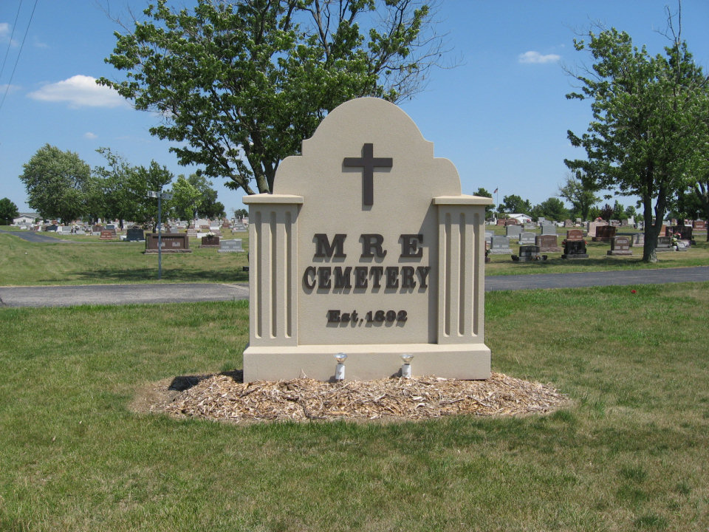
Photo by Tombstoner & Family

Oliver P. Schug, 83, a resident of Swiss Village, Berne, and a retired real estate broker, died at 10 p.m. Tuesday. He has been in poor health one year.
He was a lifelong resident of Fort Wayne, but had resided at Swiss Village since October.
Mr. Schug was a retired real estate broker, working in Allen county most of his life.
He was a member of the First Presbyterian Church in Fort Wayne.
Born October 10, 1891 in French township, he was the son of Rudolph and Mina Reppert-Schug. His wife, the former Gladys Holmes, is deceased.
Survivors include a brother, Nelson of Berne, and one sister, Mrs. Tillman (Emma) Bixler of Berne. One sister, Mrs. Austin (Stella) Gilliom and three brothers, Urban, Lester and Homer preceded him in death.
Also surviving is one foster sister, Mrs. William (Violet) Reppert-Sanders of Chattanooga, Tenn.
Funeral services will be held at 10 a.m. Friday at the Yager funeral home, with Rev. Wilson Bixler and Rev. Richard Zulauf officiating. Burial will be in the MRE cemetery. Friends may call at the funeral home after 2 p.m. Thursday.

Decatur Daily Democrat, Adams County, Indiana; Friday, January 8, 1975

Contributed by Janice Vasilovski

