Christian W. R. Schwartz
November 11, 1888 – September 16, 1951

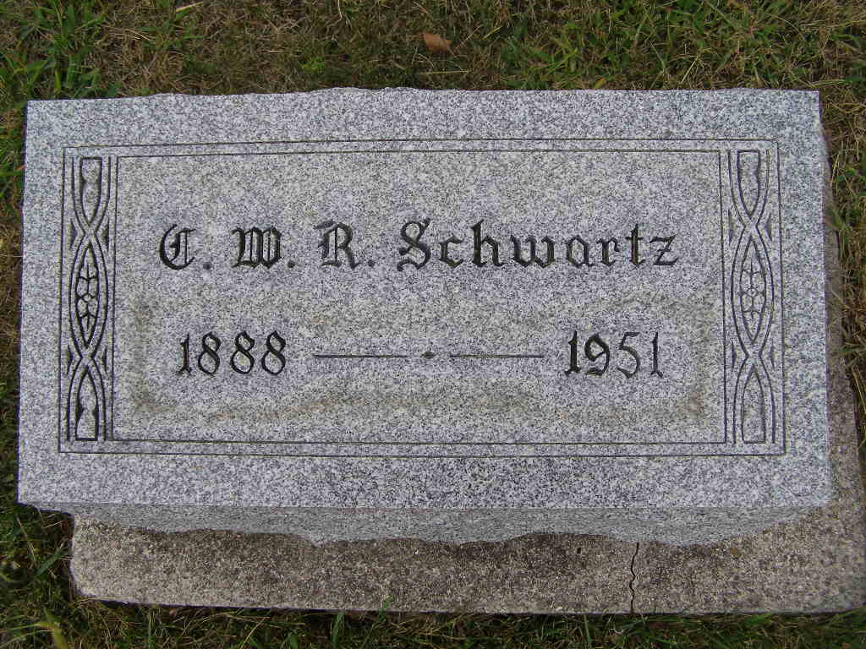
Photo by sillygirl7

(Handwritten date: Monday, Sept. 17, 1951)

C. W. R. SCHWARTZ DIES SUNDAY AT HOME NEAR HERE
Funeral Tuesday For Prominent Monroe Township Farm Leader

Christian W. R. Schwartz, 62, prominent Monroe township farmer and agricultural and community leader, died at 5:00 a.m. Sunday at his home three miles north and one half mile west of Berne. Death was caused by a cardiac condition, or heart disease. Mr. Schwartz had been ill since July. He spent a few weeks at a Fort Wayne hospital before being returned to his home.
Mr. Schwartz had been confined to his bed much of the time since he returned from the hospital, though he was able to be up occasionally. He failed gradually. His condition caused him to become very short of breath and he suffered considerably at times. He went into a coma Saturday night and never woke up, after taking a turn for the worse Friday night and Saturday.
Mr. Schwartz had suffered a heart attack a few years ago and after many weeks of hospitalization and rest, he recuperated and was up and around and active in church and community work. He has been a promoter of agricultural progress through extension work for many years. He was also actively associated with the Farm Bureau and edited the Adams County Farm News. He was widely known as an excellent photographer, a hobby he followed from his boyhood days.
Mr. Schwartz was a member of the Adams county extension committee for many years and a staunch supporter of 4-H club work. He was widely known throughout the county.
The deceased was a life-long resident of this community and was born on the same farm where he died. He was born Nov. 11, 1888, the son of Jacob J. and Marie Liechty Schwartz, both deceased. His first marriage was to Minnie Sprunger on June 16, 1910. She died December 27, 1930. He was married to Arveda Rumple October 13, 1935, at the Mennonite parsonage, Rev. C. H. Suckau officiating at the service.
Surviving are the widow and the following children: Mrs. James K. (Ruth) Brown, San Antonio, Texas; Mrs. Paul (Mary) Bahner, Monroe; Ernest Schwartz, Berne; Harold Schwartz, northeast of Berne; Mrs. Warren (Vera) Lehman, Decatur; Mrs. Max (Virginia) Sprunger, Berne; Mrs. Laverne (Anna Jane) Gilliom, Linn Grove; Mrs. Gomer (Gertrude) Kropa, Indianapolis; Larry R. Schwartz, at home; Darrel Wagner, and Mrs. Merle (Rosalyn Wagner) Kuhn, both of Angola, and Coleen Wagner, at home (cut off)
...Mrs. Peter F. Mazelin, both of Ethridge, Tenn.; Mrs. Abe Inniger, Berne route 1; Mrs. David J. Mazelin, Monroe, route 1; David J. Schwartz, Berne, route 1; Sol J. Schwartz, Phoenix, Ariz.; and Joel K. L. Schwartz, Fillmore, California.
Two brothers, John J. and Jacob J. Schwartz, and a sister, Rosina, preceded in death, also a son who died in infancy.
Mr. Schwartz was a member of the First Mennonite church where funeral services will be held at 2:00 p.m. Tuesday. Rev. Olin A. Krehbiel, pastor of the church, and Rev. W. L. Hall, pastor of the Monroe Methodist church, will officiate. Burial will be in the M.R.E. cemetery. The body is at the Yager Funeral (cut off)

Adams County, Indiana Historical Society
1933-1953 Scrapbook - Image 53
Transcribed by Karin King

