Adah V. (Baumgartner) Shank
1918 – June 16, 1971

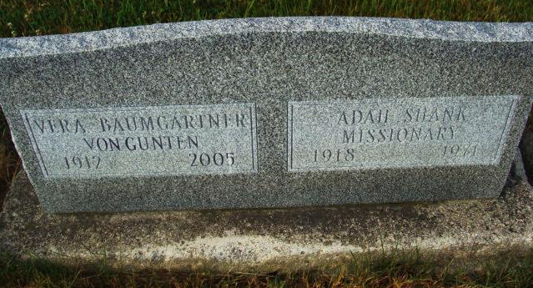
Photo by Alicia Kneuss

Mrs. Adah Shank Dies; Ex-Resident, Former Missionary

Mrs. Adah V. Shank, 52, a native of Berne, died at 5:45 am Wednesday in Bloomington Hospital. She had lived in Bloomington the past five years.
Mrs. Shank was a registered nurse and was graduated from the Lutheran School of Nursing in 1942. She and her husband, the Rev. Floyd Shank served as missionaries of the Missionary Alliance for 15 years in the Republic of Gabon, Africa.
Services will be at 2 pm Monday at the First Missionary Church with the Rev. Ken Opperman officiating. Burial will be in MRE Cemetery, Berne.
Surviving are her husband; one daughter, Miss Joann Shank, Bloomington; two sons, Stanley Shank, Chicago and Marvin Shank, Boston; her mother, Mrs. George Baumgartner, Fort Wayne; one sister, Miss Vera Baumgartner, Fort Wayne and one brother, Gordon Baumgartner, Detroit.
Friends may call at Chalfant-Perry-Klaehn Funeral Home from 7 to 9 pm Saturday, from 2 to 5 and 7 to 9 pm Sunday and at the church after 10 am Monday.

Berne (IN) Library Heritage Room
MRE Obit Book 1966-1972
Transcribed by Jim Cox

