Terry Wayne Smith
April 14, 1958 – August 18, 1972

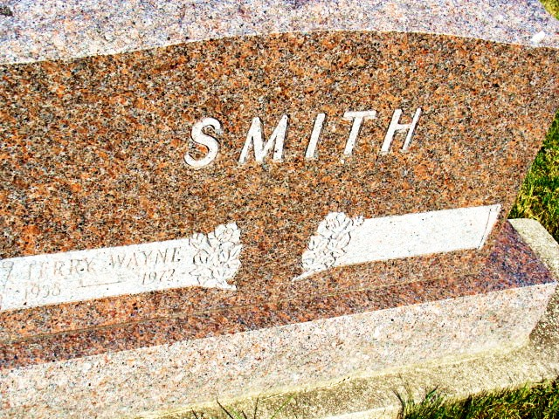
Photo by Alicia Kneuss

Death: August 18, 1972
Burial: August 20, 1972
Buried: MRE

S. A. Freshman Grid Player’s Death Was Not Football Related

Terry Wayne Smith’s death was due to a massive intra-cranial hemorrhage brought on by a congenital abnormality or a weakness since birth.
It was pointed out that the young man’s death was in no way associated with football practice and was not caused by an injury of any kind. The lad had engaged in a Pony League game Thursday night. His parents said he did not complain of not feeling well and was in a jovial mood when he left home Friday morning for football practice.
The lad had been a carrier for the Fort Wayne News-Sentinel for two years and prior to this was a Berne Witness carrier for three years. He was a member of the Liechty Foods Pony League Baseball Team.
The young man was born in Adams County April 14, 1958 and was a son of Elmer J. and Claranell Sprunger Smith. He was a popular favorite with his teammates and classmates.
Surviving are the parents; two sisters, Wanda and Karla Smith, and two brothers, Paul and Mark Smith, all at home and the maternal grandfather, Oscar Sprunger, Berne.
Services were held at 2 pm Sunday at the Trinity United Methodist Church. Dr. Home Achor, pastor of the Trinity United Methodist Church of which he was a member, officiated and burial was in the MRE Cemetery.

Berne (IN) Library Heritage Room
MRE Obit Book 1966-1972
Transcribed by Jim Cox

