Abraham “A. A.” Sprunger
February 2, 1841 – September 24, 1906
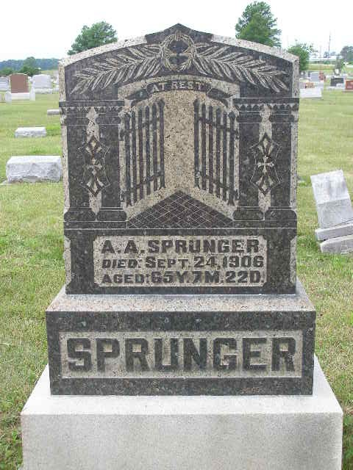
Photo by Shaunda Bedwell

BANK PRESIDENT DIES AT BERNE

BERNE, Ind., Sept. 26 - Abraham A. Sprunger, president of the Bank of Berne, and a successful business man along other lines, is dead of the grip, which he contracted last spring. He was sixty-five years old and a native of Corgemontberg, Canton Berne, Switzerland. He lived in Adams county fifty-two years, and was a conspicuous member of the Mennonite church.
He leaves a widow, ten children and twenty-six grandchildren.

Fort Wayne Journal Gazette, Allen County, Indiana; September 27, 1906

Contributed by Karin King

