Lucretia F. Sprunger
January 23, 1909 – August 21, 1969
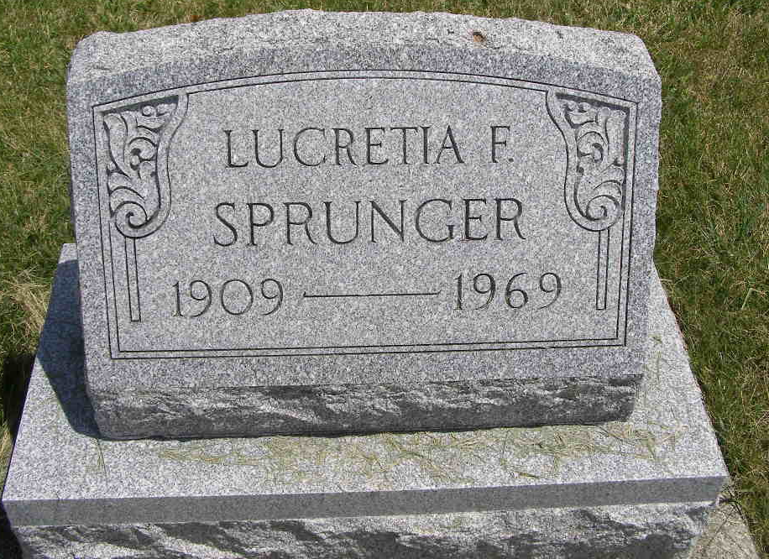
Photo by Shaunda Bedwell
Lucretia Sprunger

Date of Death: August 21, 1969 (approximately); Date of Burial: August 27, 1969
Burial: Lot 88, Original Platt

Miss Lucretia F. Sprunger, 60, Had Been Dead Several Days

Services were held at 2 pm today at the First Mennonite Church for Miss Lucretia F. Sprunger, 60, who was found dead in her home at 706 West Franklin Street Monday at 6 pm. Rev. Gordon Neuenschwander officiated and burial was in the MRE Cemetery. The Yager Funeral Home had charge of the service. The casket was not opened.
Miss Sprunger, who lived alone, had apparently been dead for several days. The time of death was fixed as late Thursday night, August 21, and is believed to have been caused by a heart attack or some other natural cause. Richard Linn, county coroner and local authorities investigated.
Her lifeless body was found by Nancy Edwards and Susan Liechty. Miss Edwards and her parents, Mr. and Mrs. Raymond Edwards, reside in the downstairs apartment of the house and Miss Liechty is a neighbor. Miss Edwards and Miss Liechty investigated after a neighbor and close personal friend, Mrs. Mary Rich, had tried to call Miss Sprunger several times by telephone and did not receive an answer. Miss Sprunger had been at an auction here last Thursday night and did not appear ill. She was not seen after that. A Thursday afternoon paper had been taken into the house, apparently by Miss Sprunger, but newspapers and mail had not been taken in after that.
A lifelong resident of this community, Miss Sprunger was born January 23, 1909, a daughter of Albert N. and Elma Welty Sprunger. She was a member of the First Mennonite Church.
Surviving are four sisters, Mrs. Herman (Celia) Hilty, Bluffton, Ohio; Mrs. Leonard (Marguerite) Wiebe, Orosi, California; Mrs. Leland (Winifred) Gerber, Bluffton, O., and Mrs. Dwight (Phyllis) Suter, Pandora, Ohio and a brother, Orlando W. Sprunger, R.R. 2, Berne.
Preferred memorials are for Swiss Village.

Berne (IN) Library Heritage Room
MRE Obits 1969 – 1972
Transcribed by Jim Cox

