Ottilia (Sprunger) Sprunger
August 23, 1885 – June 15, 1970
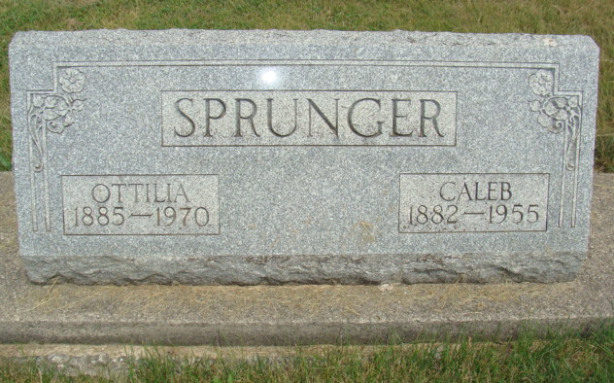
Photo by Alicia Kneuss
Otilla Sprunger

Died: June 15, 1970; Burial: June 18, 1970; Burial: Lot 40, Section 1, 4th Addition

Widow of Caleb Sprunger, 84, Taken by Death
Funeral Here Thursday for Mrs. Otilla Sprunger

Mrs. Otilla Sprunger, 84, widow of Caleb Sprunger, died at 3:10 pm Monday at Swiss Village west of Berne where she had been a resident since November 11, 1968.
She had been in failing health for some time and seriously ill since April 2 of this year, when she was transferred to the nursing care unit of Swiss Village.
A lifelong resident of this community, Mrs. Sprunger was born in Berne August 23, 1885, a daughter of Emmanuel and Katherine Stauffer Sprunger. She was married to Caleb Sprunger December 21, 1905. Her husband preceded in death in June of 1955. Mr. and Mrs. Sprunger lived on a farm east of Berne for many years where Mr. and Mrs. Sherman Von Gunten now reside.
Surviving are three daughters, Mrs. Charles (Bernice Bell, Ft. Wayne; Mrs. Wilbur (Laura) Kirchhofer and Mrs. Sherman (Naomi) Von Gunten, both of R. R. 2, Berne; a son, David W. Sprunger R. R. 2, Berne; 18 grandchildren and 21 great grandchildren; a sister, Miss Zilla Sprunger, Berne; two brothers, Arley and Silvan Sprunger, both of this city and a foster-sister, Mrs. Paul (Sarah) Liechty of R.R. 2, Berne. A daughter, who died in 1941, two brothers, Rufus and Adolph Sprunger and four sisters who died as children preceded in death.
Mrs. Sprunger was a member of the First Mennonite Church. Services will be held in the chapel of the church at 10 am Thursday, Rev. Gerald Stucky officiating. Burial will be in the MRE Cemetery.
Friends may call at the Yager Funeral Home.

Berne Heritage Room
MRE Obits 1969 – 1972
Transcribed by Jim Cox

