Roger W. Sprunger
July 27, 1921 – April 13, 1971

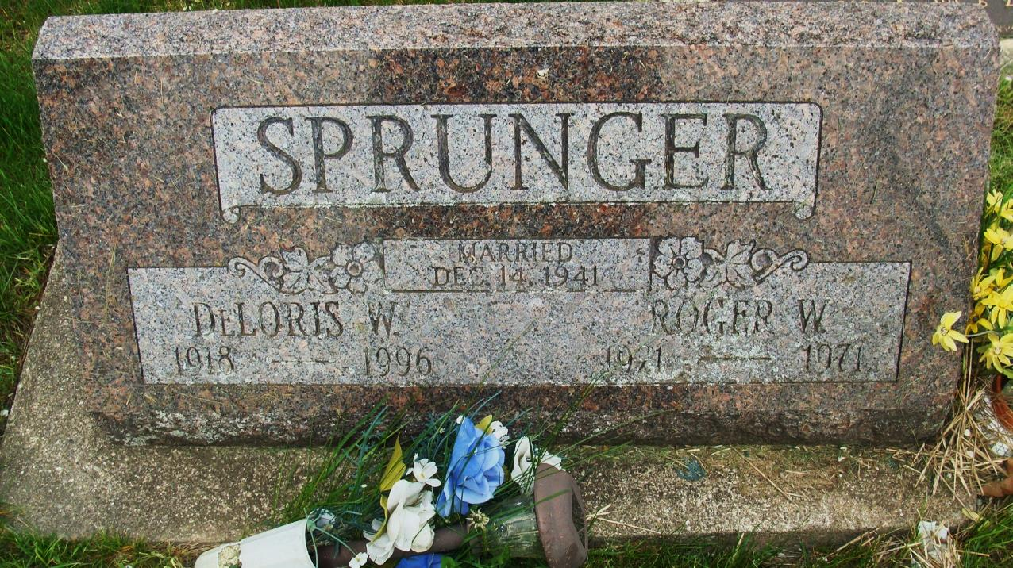
Photo by Alicia Kneuss

Date of Death: 1971, Date of Burial: April 15, 1971; Burial: MRE

R. W. Sprunger Dies Tuesday in Co. Hospital
Services Here for Local Man, 49

Roger W. Sprunger, 49, 805 Fulton Street, died at 10:10 am Tuesday at the Adams County Memorial Hospital after an illness of several months. He had been in failing health since last November.
Mr. Sprunger spent some time in the hospital the past winter, was released and returned to his home here and was up and around until about two weeks ago when he suffered a relapse and returned to the hospital.
Self-employed, Mr. Sprunger was a truck driver for many years and did considerable long distance hauling.
He was a lifelong resident of this community and was born July 27, 1921, a son of Noah and Amelia Badertscher Sprunger. He was married to Deloris Darley December 14, 1941 at Celina, Ohio.
Surviving are the wife; a son, Richard Sprunger, Berne; the mother, Berne; two brothers, Adrian Sprunger, Dana, Ohio and Stanley Sprunger, Berne and three sisters, Katherine Sprunger, Chicago; Mrs. Clarence (Helen) Buckingham, Geneva and Mrs. Larry (Marjorie) Gaskill, Berne.
Services will be held at 2 pm Thursday in the chapel of the First Mennonite Church, Rev. Gerald Stucky and Rev. Gordon Neuenschwander officiating. Burial will be in the MRE Cemetery.

Berne (IN) Library Heritage Room MRE Obit Book 1966-1972 Transcribed by Jim Cox

