Rosina (Reusser) Sprunger
1862 – July 19, 1950
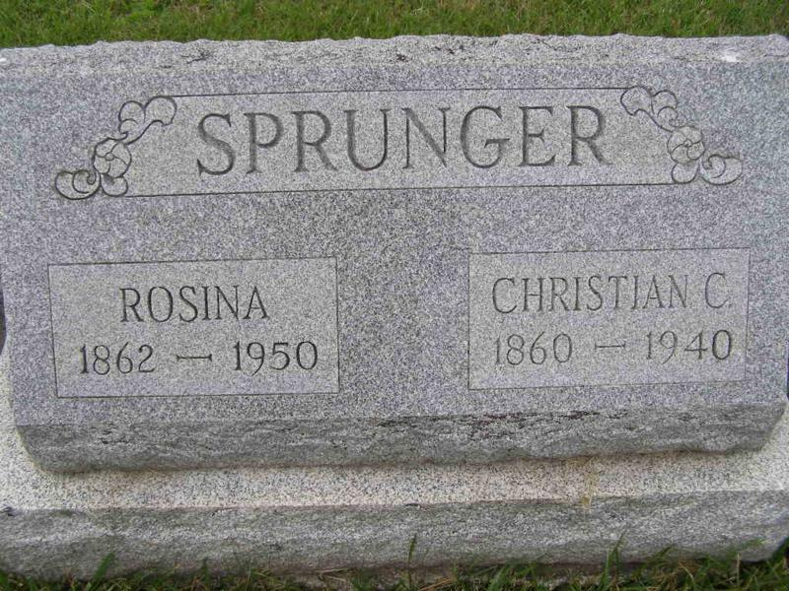
Photo by Shaunda Bedwell

Lifelong Berne Resident Dies

Berne, Mrs. Rosina Sprunger, 87, widow of C. C. Sprunger, died at 3:30 p.m. Wednesday at her home here. She was a native and lifelong resident of this community.
Surviving are six sons, Oswald, at home; Asa, Mendota, Ill.; Wesley and B. Franklin, both of Berne; Victor, Monroe Township; and Paul, Milwaukee; three daughters, Mrs. A. J. Neuenschwander, Wadsworth, O.; Mrs. Fred Reusser, Deer Creek, Okla., and Mrs. M. A. Thomas, Union City; 26 grandchildren, 26 great-grandchildren and two brothers, Dr. Amos Reusser and Henry Reusser, both of Berne.
Services will be conducted here at 10 a.m. Saturday in the First Mennonite Church, of which Mrs. Sprunger was a member. The Rev. O. A. Krehbiel will officiate, and burial will be in the MRE Cemetery.
The body, taken to the Yager Mortuary, will be returned to the residence, where friends may call after 6 p.m. Thursday.

Portland Commercial Review, Jay County, IN; July 20, 1950

