Lois Charlotte (Gilliom) Stahly
May 7, 1912 – July 17, 1972

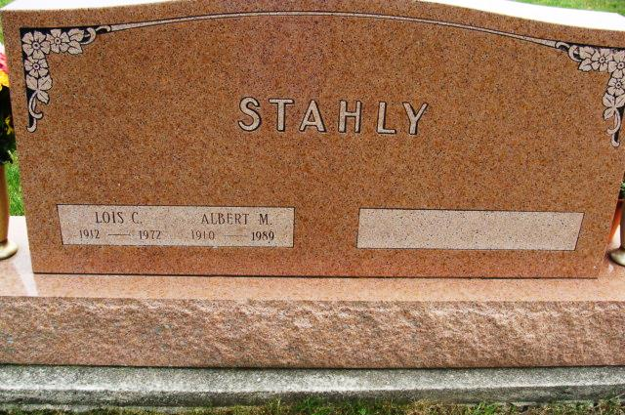
Alicia Kneuss

Death: July 17, 1972; Burial: July 19, 1972; Buried: MRE

Mrs. Lois C. Stahly, 60, wife of Albert M. Stahly of South Harrison Street, died unexpectedly in her sleep at 3 am today at her home. Death was attributed to a massive coronary.
Mr. and Mrs. Stahly had spent Sunday at their summer home on Lake Wawasee and returned home last evening. A few minutes before Mrs. Stahly’s death her husband woke and noticed her breathing was not normal. He called a doctor who responded promptly, but she died soon afterwards. She appeared in her usual health on Sunday.
Mr. Stahly is a prominent local insurance agent and Mrs. Stahly was the daughter of the founder of the local Lincoln Life Agency now operated by Mr. Stahly.
She spent most of her life in Berne and was widely known. She was a graduate of Berne High School and Northwestern University School of Music. She taught in the Mishawaka Schools after her graduation from Northwestern and then served as organist at the Cross United Church of Christ for many years. She was a member of this church.
Mrs. Stahly was born in Berne May 7, 1912, a daughter of Oswin and Lucy Reusser Gilliom. She was married to Albert M. Stahly June 20, 1937 at the First Mennonite Church.
Surviving are the husband; two sons, David E. Stahly, Indianapolis and Gregory G. Stahly, Naperville, Illinois who was just married recently and two grandchildren.
A sister preceded at the age of six and a brother, Claude, died in infancy.

Berne (IN) Library Heritage Room MRE Obit Book 1966-1972 Transcribed by Jim Cox

