Ida (Lehman) Stauffer
April 13, 1892 – August 10, 1971
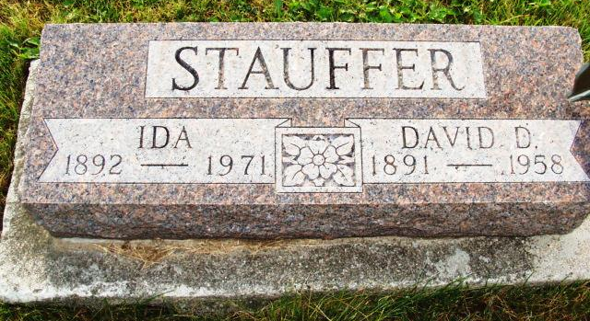
Photo by Alicia Kneuss

Ida Stauffer

Date of Death: August 10, 1971; Date of Burial: August 13, 1971
Burial: N ½ 28, Section 2, 4th Addition

Widow of David D. Stauffer, 79, Dies in West
Funeral Here Friday for Mrs. Ida Stauffer

Mrs. Ida Stauffer, 79, widow of the late David D. Stauffer, died Tuesday in a convalescent home in Torrance, California after an illness of one year. She suffered a stroke last Sunday.
Mrs. Stauffer was a lifelong resident of Berne until three years ago when she moved to Torrance where her only daughter resides. Mr. and Mrs. Stauffer lived in the south part of Berne, in the house where Mr. and Mrs. James Hill and family now reside at 662 Hendricks Street.
A native of Berne, Mrs. Stauffer was born April 13, 1892, a daughter of David C. and Elizabeth Liechty Lehman. She was married to David D. Stauffer, longtime a cream buyer and ice cream dealer here and he preceded in death several years ago.
Surviving are a daughter, Mrs. Harry (Bette) Ingrahm, Torrance California; four grandchildren; two great-grandchildren and four sisters, Mrs. Elda Moser, Mrs. Elmer (Bertha) Baumgartner, Mrs. Lydia Habegger and Mrs. Tilman (Elma) Steiner, all of Berne.
A son, Major Ornell J. Stauffer lost his life in World War II as a pilot. Also deceased are the following brothers and sisters: Calvin benhard, Rufus and David D. Lehman, and Mrs. William Von Gunten, Mrs. Walter Stucky and Mrs. Rhodella Simpson.
The body is being returned to the Yager Funeral Home here and services will be held at 3 pm Friday. Rev. Gerald Stucky will officiate and burial will be in MRE Cemetery.
Mrs. Stauffer was a member of the local First Mennonite Church.

Berne (IN) Library Heritage Room
1969 – 1972 Obits
Transcribed by Jim Cox

