Christina Steiner
December 25, 1870 – November 8, 1945
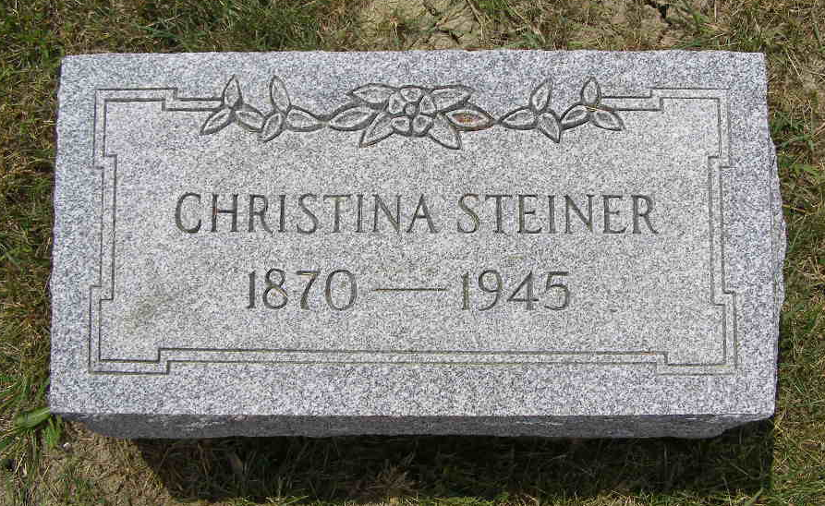
Photo by Shaunda Bedwell

(Handwritten date: Friday, November 9, 1945)

MISS CHRISTINA STEINER DIES AT HER HOME HERE
Funeral Here Saturday For 74-Year-Old Local Woman

Miss Christine Steiner, 74, a lifelong resident of Berne and community, died at 1:30 o'clock Thursday morning at her home just east of the corporation line on Road 118. Death was caused by heart disease. She had been ill since the middle of last June and gradually grew weaker the past several weeks. She had lived at the present home the last 46 years, ever since moving from the farm northwest of Berne.
The deceased was born in French township, Adams county, on Christmas Day, December 25, 1870, a daughter of Jacob and Elizabeth Liechty Steiner. She was never married. Miss Steiner was employed at the Nussbaum Novelty Company and the Globe Hatchery for many years.
Surviving are the following brothers and sisters: John Steiner, Berne; Jacob Steiner, French township; Mrs. Eli (Rebecca) Riesen, Berne; Miss Mary Steiner, Berne and Mrs. Dan (Anna) Stauffer, Berne. Three brothers and a sister preceded, Samuel, Frederick, one in infancy and Sarah.
Miss Steiner was a member of the Mennonite church. The funeral will be held at 2 o'clock Saturday at the church, following a short service at the home. The Rev. Olin A. Krehbiel will officiate. Burial will be in the M.R.E. cemetery. The body was taken to the home Thursday evening from the Yager mortuary.

Adams County Historical Museum
1933-1953 Scrapbook, Image 006
Transcribed by Karin King

