Dorothy Eliza (Moser) Steiner
July 12, 1922 – October 23, 2013

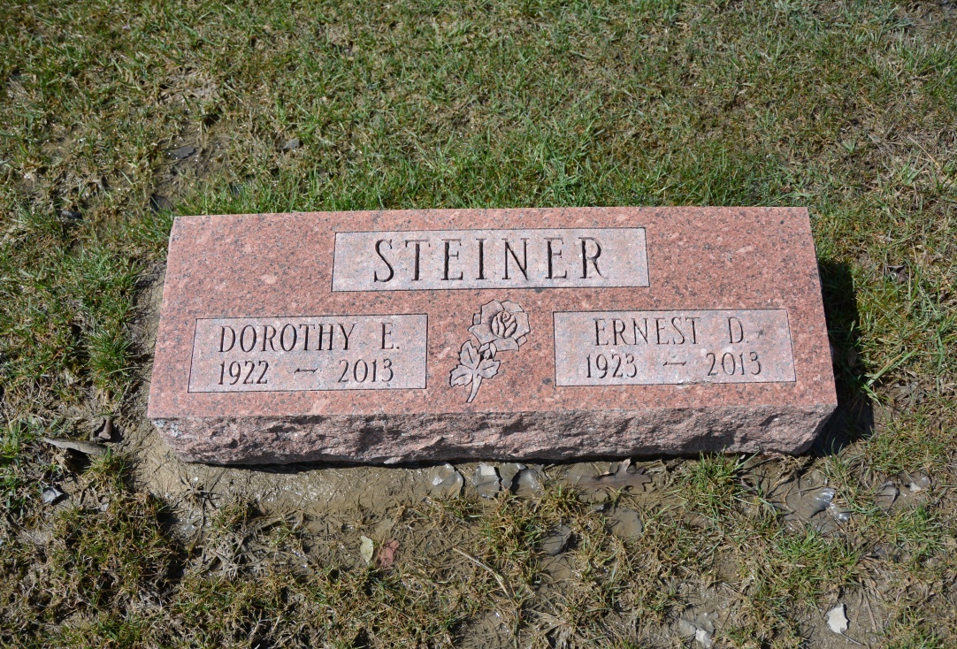
Photo by Deb Curry

Dorothy E. Steiner, 91, of Berne, IN, passed away at 10:40 PM on Wednesday, October 23, 2013 at Swiss Village in Berne, IN. She was born on Wednesday, July 12, 1922, in Adams Co., IN. She married Ernest Steiner on Sunday, August 30, 1953 in Berne, IN. Dorothy was a graduate of Hartford Township High School. She worked for 32 years at Nussbaum Novelty in Berne. Dorothy enjoyed quilting and embroidering. She was a member of the West Missionary Church in Berne.
Survivors include: Husband - ErnestSteiner, Berne, IN., Brother - Frank Moser and Several Nieces & Nephews. She was preceded in death by her: Father - Jacob Moser, Mother - Lillian (Mertz) Moser, Brother - Harry Moser and Sister - Edwina Newhouser.
The family had a private graveside service for Dorothy on Monday, October 28, 2013 with Rev. Jerry Flueckiger officiating. Interment followed in the M.R.E. Cemetery in Berne.
Arrangements are being handled by Downing & Glancy Funeral Home in Geneva.

Downing & Glancy Funeral Home online obit (accessed 10/30/2013)

