Lydia E. (Yoder) Steiner
April 29, 1891 – May 19, 1968
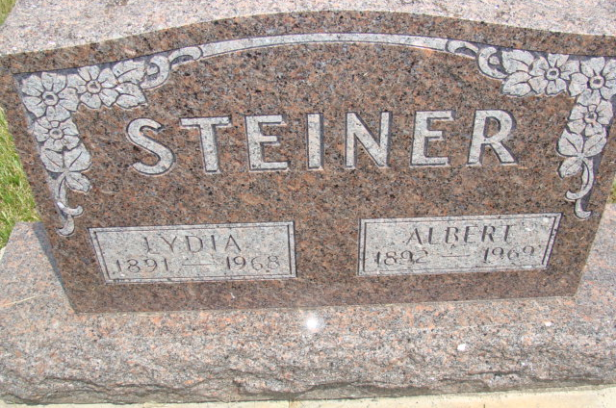
Photo by Alicia Kneuss
Lydia Steiner
Date of Death 1968
Date of Burial: Tuesday, May 25, 1968
Burial: S ½ Lot 55, Sec. 1 – 4th Addition

Rites Saturday for Mrs. Albert Steiner

Funeral services will be held at 2 pm Saturday at the West Missionary Church for Mrs. Lydia Steiner, 77, wife of Albert Steiner of Hartford Township, a mile south of Linn Grove. Mrs. Steiner died at 11 am Wednesday at the Adams County Memorial Hospital. She had been ill since Christmas and bedfast since April 21.
Rev. Frank Armstrong, pastor of the West Missionary Church and Rev. Veryl Roth, pastor of the Evangelical Mennonite Church, will officiate and burial will be in the MRE Cemetery. Friends may call at the Yager Funeral Home.
Mrs. Steiner was born in Wabash Township April 29, 1891, a daughter of Peter and Fannie Moser Yoder. She is a lifelong resident of this community and was a member of the West Missionary Church.
Surviving are the husband; two daughters, Mrs. Howard (Luella) Moeschberger and Mrs. Kenneth (Lorene) Wanner, both of this community; four grandchildren and two great-grandchildren and three brothers, Henry Yoder, Berne and Levi and Elmer Yoder, Linn Grove. A sister, Mrs. William Amstutz, preceded in death.
Berne Library (IN) Heritage Room MRE Obit Book 1966-1972, image 145 Transcribed by Jim Cox

