Robert D. Steury
December 25, 1935 – August 3, 2018

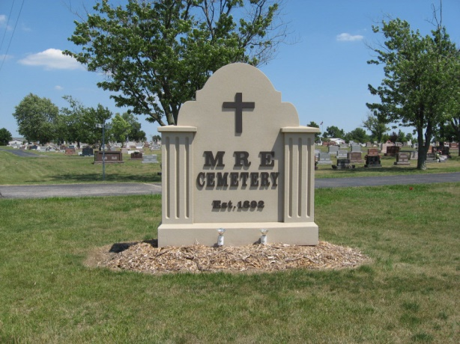
Photo by Tombstoner & Family

Robert D. "Bob" Steury, Noblesville, IN., formerly of Berne passed away on August 3, 2018 in Westfield. He was born to Menno and Rosina Schwartz on December 25, 1935 in Adams County, IN. He married Janet Brand of Ashley, IN, on June 26, 1960.
Bob graduated from Adams Central Schools and attended the West Missionary Church. He was employed at CTS Corp, Berne for over 35 years and he and Janet owned the K&S Cake and Candy Supply Haus, Berne for over 21 years. Bob was a veteran serving in the National Guard from 1958-1964. His interests included gardening and caring for his flowers
Survivors include: daughters, Sheryl (Jason) Welch of Berne, Sheila (John) Carnes of New Castle, sons, Kent Steury of Noblesville, Keith Steury of San Francisco, CA., grandchildren; Kent (Raquel) Steury, Klark, Maggi Steury, Charles (Steury) Carnes, Shadrack, Shayla, Jena Welch, and great-grandson, Kub Steury; sisters Betty (Robert) Reinhard of Berne, Lois (Dean) Williams of Coldwater, MI., Nancy (Bob) Dye of Idaho.
Mary Jane Brindamour of New Hampshire, Linda (John) Paul of Albion, brother; Ron (Barbara) Steury of Sheridan, MI., and
Preceding in death are his parents, step-mother Velma Augsburger Steury, and brother Palmer Steury.
His services are on Saturday, August 11, 2018 at 10:30 am at the West Missionary Church with visitation 1 hour prior to services. Visitation also Friday, August 10 from 4 to 8 pm at the Yager-Kirchhofer Funeral Home, Berne. Officiating is Pastor Keith Rupp. Burial is in the MRE Cemetery.
Preferred memorials are to the Adams County Community Foundation- Cancer Fund.

Yager-Kirchhofer Funeral Home online obit (accessed August 4, 2018)

