Caroline Christine (Baker) Stuckey
1869 – July 1, 1953

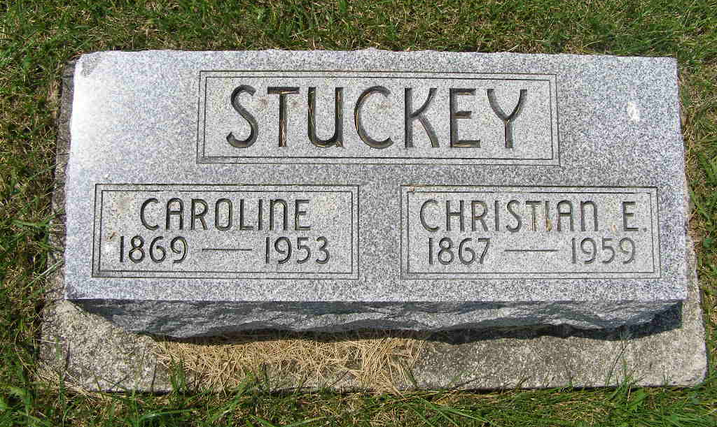
Photo by Shaunda Bedwell

(Handwritten date: Wednesday, July 1, 1953; age 83)

WIFE OF C. E. STUCKEY DIES AT (cut off)
(handwritten: Caroline Christine Baker Stuckey)
Wife of C. E. Stuckey Dies At Home Here Today (continued from page 1)

...was married to C. E. Stuckey August 25, 1888 at Chattanooga, Ohio. The couple enjoyed more than 64 years of married life together. (Handwritten: Daughter of Jacob and Caroline Bollenbacker Baker)
Surviving in addition to the husband are the following: Rev. Walter J. Stuckey, Wabasha, Wisconsin; Homer C. Stuckey, Fort Wayne; Estella M. Stuckey, at home; Mrs. Calvin (Lulu) Sprunger, Berne; Mrs. Homer (Irene) Winteregg, Monroe; Leslie J. Stuckey, Berne; Mrs. Adolph (Ruth) Ferber, Fort Wayne and Carl E. Stuckey, Decatur. Seventeen grandchildren and 15 great-grandchildren survive. The following brothers and sisters survive: Lewis, Jacob and Henry Baker, all of Chattanooga, Ohio; T. A. Baker, Celina, Ohio; Mrs. Mary Stuckey, Rockford, Ohio, R.R.; Mrs. Albert Germann, Celina, Ohio; Mrs. M. A. Linn, Celina, Ohio rural route and Mrs. Fredona Germann, Ohio City, Ohio.
Two sisters and one brother preceded in death.
Mrs. Stuckey was a member of the Cross Evangelical and Reformed church where services will be held at 10:00 a.m. Friday, Rev. C. A. Schmid officiating. Burial will be in the M.R.E. cemetery. The body is at the Yager Funeral Home where friends may call after 7:00 p.m. today.

Adams County Historical Museum
1933-1953 Scrapbook, Image 033
Transcribed by Karin King

*****
OHIO CITY WOMAN'S SISTER SUCCUMBS

Mrs. C. E. Stuckey, 83, sister of Mrs. Fredona Germann of Ohio City, died Wednesday at her home in Berne, Ind. She had been in failing health since last October. The deceased, a native of Mercer County, is survived by her husband, four sons, four daughters, four brothers, four sisters, 17 grandchildren and 15 great-grandchildren. Services will be conducted at 10 a.m. Friday in the Cross EUB Church. Burial will be in the MRE Cemetery.

Van Wert Times Bulletin, Van Wert County, Ohio; July 2, 1953

