Metta (Nussbaum) Stucky
April 26, 1895 – April 21, 1971

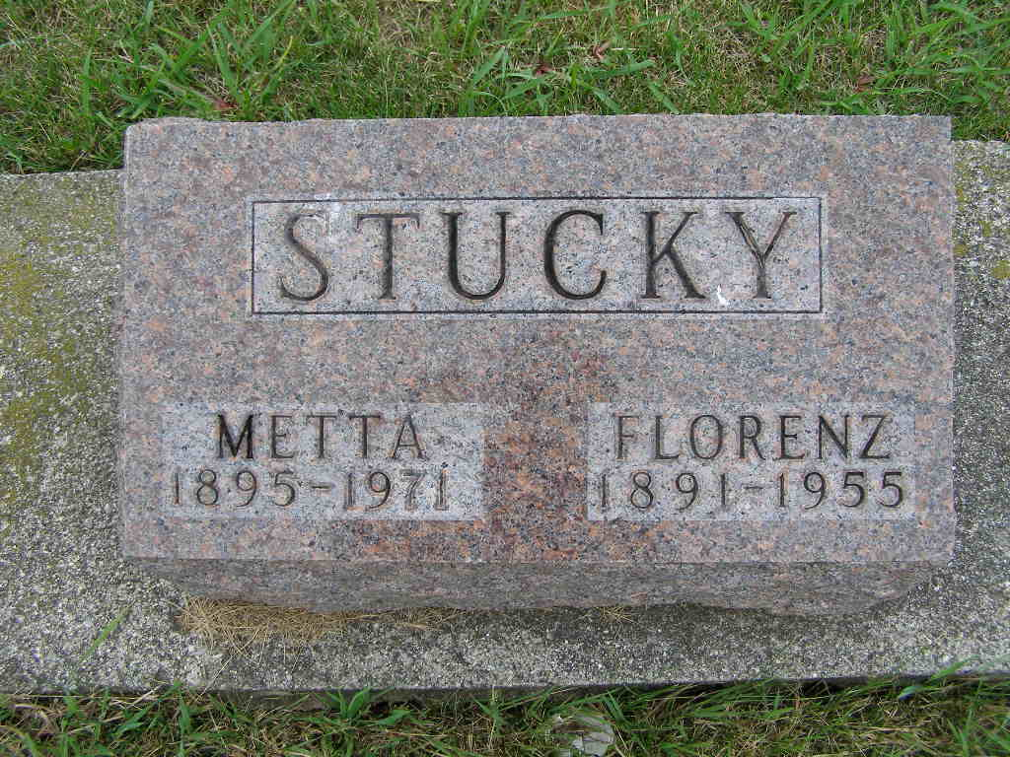
Photo by Shaunda Bedwell

Date of Death: 1970 [should be 4/21/1971]
Date of Burial: April 23, 1970; Burial: Lot 73, Original Platt

Rites For Mrs. Metta Stucky Held Here Today
Local Woman, 75, Dies Wednesday at Decatur Nursing Home

Services were held at 2 pm today at the First Mennonite Church for Mrs. Metta Stucky, 75, widow of Florenz Stucky, who died at 11:40 am Wednesday at the Lakeview Nursing Home in Decatur where she had been a patient for eight weeks. Death followed an extended illness.
Before entering the nursing home, Mrs. Stucky resided at 556 Park Avenue in Berne.
Rev. Gordon Neuenschwander and Rev. Gerald Stucky officiated and the service in charge of the Winteregg-Linn Funeral Home of Decatur. Burial was in the MRE Cemetery.
A lifelong resident of this community, Mrs. Stucky was born here April 26, 1895, and was the daughter of John and Ellen Baumgartner Nussbaum. She was married to Florenz Stucky December 7, 1913 and he preceded in death March 1, 1955.
She was a member of the First Mennonite Church.
Surviving are six daughters, Mary Ann, at home; Mrs. Doyle (Leona) Mathys, Berne; Mrs. James (Celeste) Garboden, Geneva; Mrs. Donald (Helen) Lautzenheiser, Berne; Mrs. Gerhard (Ruby) Brouer, Fort Wayne; Mrs. Norman (Bonnie) Wall, Bluffton; five sons, Ralph, Celina, Ohio; Roy, Alfred and Max, all of Decatur and John D., Fort Wayne; 29 grandchildren and 12 great-grandchildren; three sisters, Mrs. Everett (Elda) Reynolds, Elkhart; Mrs. Frank (Lydia) Burke and Mrs. Vernal (Edna) Ellenberger, both of Berne and nine brothers, Frank, Fred, Edwin, Benhart, Wilbert, Albert, Victor, Rev. John and Hiram Nussbaum, all of Berne community.

Berne (IN) Library Heritage Room MRE Obit Book 1966-1972 Transcribed by Jim Cox

